

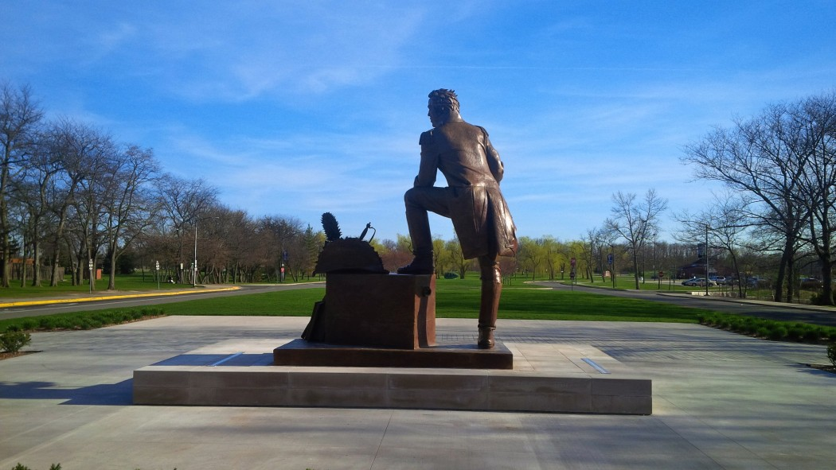
Health, Safety & Wellness Orientation

for Departmental Chairs

VERSION 1.5

Table of Contents
Introduction | Page 3
Occupational Health & Safety Act | Page 3
Internal Responsibility System | Page 3
Occupational Health & Safety Policy | Page 4
Mandatory Health & Safety Training Requirements | Page 4
Health & Safety Hazard Reporting | Page 5
Workplace Violence | Page 5
Work Refusal | Page 5
Workplace Injury/Illness | Page 7
Workplace Safety & Insurance Board (WSIB) Reporting | Page 8
Short Term Disability (STD) | Page 9
Long Term Disability (LTD) | Page 9
Medical Accommodations | Page 10
Wellness | Page 10
Employee & Family Assistance Plan | Page 10
Ergonomic Assessments | Page 11
Asbestos Management Program | Page 11
Biological & Lab Safety | Page 12
Controlled Biohazard Activities | Page 13
Science Safety Training Offerings | Page 13
Academic Safety Committee | Page 14
Brock Emergency Procedures | Page 14
First Aid Stations & Artificial External Defibrillators (AEDs) | Page 15
Joint Health & Safety Committee | Page 15
Student Unpaid Placements | Page 16
Certificates of insurance | Page 16
Event Risk Management | Page 17
University Risk Management | Page 17
Health, Safety & Wellness Contacts | Page 18

Introduction
Health, Safety & Wellness (HSW) strives to empower and enable faculty and staff through supportive and resourceful leadership to engage and create a healthy, safe and well workforce. Technical expertise is provided by HSW to the university community through the development, implementation, and maintenance of sustainable programs and processes in areas related to occupational health & safety, academic and lab safety (including biosafety); environmental safety; fire safety (in partnership with Campus Security Services); the University’s insurance program; short- and long-term disability; university risk management; Workplace Safety & Insurance Board (WSIB) claims management; ergonomic assessments; management of workplace accommodations, employee wellness initiatives and risk management.

Occupational Health & Safety Act
Overview
The Ontario Occupational Health & Safety Act (OHSA) defines a supervisor as a person who has charge of a workplace or authority over a worker. Brock University is committed to meeting its duties under the OHSA, including appointing supervisors and ensuring they are competent to meet their supervisory duties.

A worker who has charge of a workplace with the duty and the effective power to “ensure” that workers comply with the OHSA and applicable university policies and procedures attract supervisory status.

A Department Chair may not have the formal power to sanction or reward a worker; however, this is not a requirement for supervisory status under the OHSA. The effective power to “ensure” may be found simply when a worker is close to the work (or “hands on”) and is expected to address safety issues.

Duties of supervisor
27. (1) A supervisor shall ensure that a worker,
(a) Works in the manner and with the protective devices, measures and procedures required by this Act and the regulations; and
(b) Uses or wears the equipment, protective devices or clothing that the worker’s employer requires to be used or worn.

Additional duties of supervisor
(2) Without limiting the duty imposed by subsection (1), a supervisor shall,
(a) Advise a worker of the existence of any potential or actual danger to the health or safety of the worker of which the supervisor is aware;
(b) Where so prescribed, provide a worker with written instructions as to the measures and procedures to be taken for protection of the worker; and
(c) Take every precaution reasonable in the circumstances for the protection of a worker. R.S.O. 1990, c. O.1, s. 27.

Have questions or concerns?
Leigh Harold, Director, Health, Safety & Wellness lharold@brocku.ca or ext. 3123

Internal Responsibility System
As per the OHSA, the Internal Responsibility System (IRS) is the fundamental philosophy and foundation of occupational health and safety legislation that everyone has direct responsibility for health and safety as an essential part of his or her job. More specifically, regardless of location or position within an organization, each individual takes initiative on health and safety issues and works to solve problems and make improvements on an on-going basis.

As per the Ministry of Labour (MOL), supervisors are responsible for making workers fully aware of the hazards that may be encountered on the job or in the workplace; ensuring that they work safely, responding to any of

the hazards brought to their attention, including taking every precaution reasonable in the circumstances for the protection of a worker.

Have questions or concerns?
Leigh Harold, Director, Health, Safety & Wellness lharold@brocku.ca or ext. 3123

Occupational Health & Safety Policy
The OHSA requires all employers to have a health and safety policy. The policy defines the University’s on-going commitment to health and safety, outlines the roles and responsibilities and ensures compliance with the OHSA. The policy applies to every Brock University worker as defined in the Act.

The Occupational Health & Safety policy is available from OneBrock under Health, Safety & Wellness. In addition, the policy is posted on Health & Safety Boards across campus and is available on the University Secretariat web-page.
All employees of Brock, regardless of their position, are expected to review and understand the Health & Safety Policy. All employees shall work safely and promote a positive health and safety culture. Other requirements include: complying with the requirements of legislation, internal policies, standards, programs and procedures

In addition, all employees have a duty and are required to report hazards or legislative contraventions immediately. Finally, health and safety concerns expressed by faculty or administrative employees to Departmental Chairs must be investigated and dealt with appropriately.

Have questions or concerns?
Leigh Harold, Director, Health, Safety & Wellness lharold@brocku.ca or ext. 3123

Mandatory Health & Safety Training Requirements
Health & Safety Awareness Training (HSAT)
All employees, regardless of their position or role, are required to complete the HSAT module which is available from Sakai. The training available from Sakai addresses concepts and specific information for both supervisors and employees. HSAT only needs to be completed one (1) time. HSW has developed a helpful HSAT Bulletin which provides answers to frequently asked questions about HSAT. Completion statistics and reports are shared via OneDrive.

Workplace Violence Training
All employees, regardless of their position or role, are required to complete the Workplace Violence Training module which is available from Sakai. Workplace Violence Training only needs to be completed once.

Workplace Hazardous Materials Information System Training (WHMIS)
Employees working in close proximity to or directly with hazardous materials/physical agents are also required to the complete WHMIS training available from Sakai. Refresher training is required annually. HSW has developed a helpful WHMIS Bulletin which provides answers to frequently asked questions regarding WHMIS training.

Have questions or concerns?
Be Safe besafe@brocku.ca or ext. 7233
Dan Pozzobon, Occupational Health & Safety Specialist dpozzobon@brocku.ca or ext. 5994
Leila Vistorte, Lab Safety Specialist lvistorte@brocku.ca or ext. 6179
Brian Dzurban, Occupational Health & Safety Specialist bdzurban@brocku.ca or ext. 3284

Health & Safety Hazard Reporting
A health and safety hazard is a specific environmental circumstance, act or behaviour that has an existing or potential ability to cause damage to equipment/property or result in an injury or adverse health effects to an individual.

Have questions or concerns?
Be Safe besafe@brocku.ca or ext. 7233
Dan Pozzobon, Occupational Health & Safety Specialist dpozzobon@brocku.ca or ext. 5994
Brian Dzurban, Occupational Health & Safety Specialist bdzurban@brocku.ca or ext. 3284

Workplace Violence
- The exercise of physical force by a person against a worker, in a workplace, that causes or could cause physical injury to the worker

- An attempt to exercise physical force against a worker, in a workplace, that could cause physical injury to the worker

- A statement or behaviour that is reasonable for a worker to interpret as a threat to exercise physical force against the worker, in a workplace, that could cause physical injury to a worker

More information including the Workplace Violence Policy can be found by visiting Health, Safety & Wellness via OneBrock.

Have questions or concerns?
Be Safe besafe@brocku.ca or ext. 7233
Dan Pozzobon, Occupational Health & Safety Specialist dpozzobon@brocku.ca or ext. 5994

Work Refusal
A worker may refuse to work, or do particular work where he or she has reason to believe that:
- Any equipment, machine, device or thing the worker is to use or operate is likely to endanger himself, herself or another worker;
- The physical condition of the workplace or the part thereof in which he or she works or is to work is likely to endanger himself or herself;
- Workplace violence is likely to endanger himself or herself; or
- Any equipment, machine, device or thing he or she is to use or operate or the physical condition of the workplace or the part thereof in which he or she works or is to work is in contravention of this Act or the regulations and such contravention is likely to endanger himself, herself or another worker

In the event of any of the scenarios outlined above, the employee must immediately tell the responsible Supervisor or Employer that the work is being refused and explain why.
The initiation of the work refusal process could result in a multi-stage investigation that can involve an Employee, Supervisor, Employer, Joint Health & Safety Committee member and representatives from the Ontario Ministry of Labour.
Faculty and staff shall work safely and comply with the requirements of legislation, internal policies, standards, programs and procedures. Faculty and staff have a duty to report hazards or legislative contraventions immediately to their Supervisor or someone in authority. All parties are expected to participate in the work refusal process.

Have questions or concerns?
Be Safe besafe@brocku.ca or ext. 7233
Dan Pozzobon, Occupational Health & Safety Specialist dpozzobon@brocku.ca or ext. 5994

Workplace Injury/Illness
Reporting and documenting workplace injuries and illness is a compliance requirement. The reporting process greatly assists in the identification of issues, concerns and hazards so appropriate actions can be taken to eliminate the hazard or mitigate further injuries or illness. This is done so through investigating in order to understand issues, concerns and hazards. The Injury/Incident Report Form can also be used to record “near miss” hazards and incidents that involve members of the Brock community. This embodies and supports the IRS.

Injury/Illness Reporting Flow
Have questions or concerns?
Be Safe besafe@brocku.ca or ext. 7233
Dan Pozzobon, Occupational Health & Safety Specialist dpozzobon@brocku.ca or ext. 5994
Brian Dzurban, Occupational Health & Safety Specialist bdzurban@brocku.ca or ext. 3284

Workplace Safety & Insurance Board (WSIB) Reporting
Depending on the circumstances or the significance of the injury/illness there may be additional reporting requirements and timelines.

More specifically, if any or a combination of the following is applicable than the circumstances of the incident and injury/illness must to be reported to the WSIB within seventy-two (72) hours of notification by the University:
- A worker requires healthcare
- Misses work beyond the date of the incident
- Requires work modification

The moment there is knowledge of one (1) or a combination of the above conditions, consultation with Health Management is required. This ensures the Univeristy adheres to the legislative requirement of the Early and Safe Return to Work process.

To ensure the University meets the requirement of the Early and Safe Return to Work Policy of the WSIB, the Health Management team within HSW manages the return to work component of WSIB claims. This is legislatively driven by the Workplace, Safety & Insurance Act.

Any staff or faculty member that will be out of the province of Ontario for greater than six (6) months for the purpose of work related activities is required to notify the Health Management team. In order for WSIB coverage to be extended beyond 6 months, the date of departure and anticipated return date as well as the destination must be reported.

The WSIB can levy fines for late and incomplete reporting. Please ensure your department submits all incident information to Health, Safety & Wellness within one (1) business day to avoid fines being imposed on the University. In the event the delay of reporting occurs at the employee, or supervisor level, the ensuing fine will be charged to the department responsible for the delay.

Have questions or concerns?
Be Safe besafe@brocku.ca or ext. 7233
Cara Kirkham, Health Management Consultant ckirkham@brocku.ca or ext. 4237
Kathryn Walker, Manager, Health Management & Wellness kwalker6@brocku.ca or ext. 6086

Short Term Disability (STD)
The University understands that not all non-occupational illnesses and injuries require an employee to be absent from work. However, when an employee is unable to attend work due to illness or injury for five (5) days or greater, or when an employee is absent repeatedly over time; the Health Management team shall be notified and the employee will be provided with the Brock University Attending Physician’s Statement form to be completed by a legally licensed doctor of medicine.

All pertinent information and resources are reviewed for determination of initial and ongoing eligibility of STD/sick benefits. The medical documentation is maintained ​in a confidential health management file for the purpose of determining eligibility for STD benefits and for return to work planning. Only restrictions, limitations and abilities are provided to the Supervisor. The STD period is 105 calendar days per illness / injury. To ensure a seamless transition from STD to LTD, the University evaluates the STD claim consistent with the contractual requirements of the LTD policy.

To access a process flow chart on the Short Term Sick Process and Return To Work, to learn more about roles and responsibilities or to access the Attending Physician’s Statement (medical certificate), please visit the Short Term Disability page on OneBrock.

For the purposes of a medical leave of absence, medical accommodation or return to work planning from a medical leave, the Dean will receive copies of all correspondence as it pertains to the individual’s medical leave and limitations and restrictions upon return to work. It will be at the Dean’s discretion to disseminate this information with the relevant parties for planning purposes.

Have questions or concerns?
Cara Kirkham, Health Management Consultant besafe@brocku.ca or ext. 4237
Kathryn Walker, Manager, Health Management & Wellness kwalker6@brocku.ca or ext. 6086

Long Term Disability (LTD)
The University’s current carrier adjudicates Long Term Disability (LTD) claims. An employee is eligible to submit an application for LTD benefits when the Health Management team has confirmed through receipt of appropriate medical documentation that the employee will be disabled for the entire 105 calendar day STD period.

Those employees who remain disabled for the 105 calendar day waiting period for LTD will be provided with appropriate documentation. During the 105 calendar day STD period, the Health Management team may request early intervention which is a voluntary service from the University’s current carrier to assist with facilitation of treatment.

The Health Management team facilitates the LTD application process and maintains involvement until the carrier has reached a decision on entitlement to LTD benefits. There are additional services available through OTIP for individuals requiring resources related to Mental Health or Cancer Care. More information is available from the Long Term Disability page on OneBrock.

For the purposes of a medical leave of absence, medical accommodation or return to work planning from a medical leave, the Dean will receive copies of all correspondence as it pertains to the individual’s medical leave and limitations and restrictions upon return to work. It will be at the Dean’s discretion to disseminate this information with the relevant parties for planning purposes.

Have questions or concerns?
Cara Kirkham, Health Management Consultant ckirkham@brocku.ca or ext. 4237
Kathryn Walker, Manager, Health Management & Wellness kwalker6@brocku.ca or ext. 6086

Medical Accommodations
The University Employment Accommodation Policy provides employees whose disabilities preclude them from performing the essential requirements of their jobs, or who cannot meet bona fide and reasonable occupational requirements, with appropriate accommodation with respect to employment.

Medical documentation is required to approve a temporary or permanent request for accommodation. The Health Management team, within Health, Safety & Wellness, the supervisor, the employee and the Union, if applicable, shall establish an accommodation plan.

To access a process flow chart on the Medical Accommodation Process, the Request for Medical Accommodation Form (medical certificate) or to access the Employment Accommodation Policy, please visit the Accomodation Request page from OneBrock.

For the purposes of a medical leave of absence, medical accommodation or return to work planning from a medical leave, the Dean will receive copies of all correspondence as it pertains to the individual’s medical leave and limitations and restrictions upon return to work. It will be at the Dean’s discretion to disseminate this information with the relevant parties for planning purposes.

Have questions or concerns?
Cara Kirkham, Health Management Consultant ckirkham@brocku.ca or ext.4237
Kathryn Walker, Manager, Health Management & Wellness kwalker6@brocku.ca or ext. 6086

Wellness
Various wellness initiatives are offered throughout the year to employees and are listed on the monthly wellness calendar along with events happening on campus and in the community. These wellness initiatives encompass eight (8) areas of Wellness including: emotional, financial, social, spiritual, occupational, physical, intellectual and environmental wellness.

In addition, Employee Wellness Day is held annually and occurs most often in June. The day is comprised of staff and faculty being offered an opportunity to attend a variety of workshops throughout the day that they find meaningful to their own well-being. For more invormation and event calendars please visit the Wellness page on OneBrock.

Have questions or concerns?
Wellness wellnessday@brocku.ca
Cara Kirkham, Health Management Consultant ckirkham@brocku.ca or ext. 4237
Kathryn Walker, Manager, Health Management & Wellness kwalker6@brocku.ca or ext. 6086

Employee & Family Assistance Plan
The University’s carrier, Shepell-fgi is an accredited organization which provides Employee and Family Assistance Program (EFAP) services to those eligible employees and their eligible dependents. Shepell-fgi is a leading EFAP service provider and offers a wide range of confidential and voluntary support services to assist in resolution of everyday challenges, complex issues, and everything in-between.

The service is available at no cost to the eligible employees listed below, 24 hours a day, 7 days a week by calling 1-800-387-4765.

EFAP services are part of the benefit package for eligible employees in the following employee groups:

- Administrative, Professional and Exempt | - CUPE 4207, Unit 3
- CUPE 1295 | - IATSE
- CUPE 2220 | - OSSTF
- CUPE 4207, Unit 2 | - Senior Administrative Council

For more information on the services that Shepell-fgi offers, please visit the Employee & Family Assistance Plan page from One Brock.

Have questions or concerns?
Cara Kirkham, Health Management Consultant ckirkham@brocku.ca or ext.4237
Kathryn Walker, Manager, Health Management & Wellness kwalker6@brocku.ca or ext. 6086

Ergonomic Assessments
An online Ergonomic Module is available to assist staff and faculty in reviewing their office workstation. This module will guide employees through optimal setup and provide tips for changing positions throughout the day. The training module is available from Sakai.

Completion of the Ergonomic Module is the first step in an ergonomic review and it is recommended that the employee wait a minimum of 1-2 weeks after making adjustments to equipment to determine if additional assistance may be required.

If after one (1) to two (2) weeks you have ongoing concerns, a one-on-one assessment for additional assistance to provide recommendations on the workspace is available.

Have questions or concerns?
Cara Kirkham, Health Management Consultant ckirkham@brocku.ca or ext. 4237
Kathryn Walker, Manager, Health Management & Wellness kwalker6@brocku.ca or ext. 6086

Asbestos Management Program
Asbestos was commonly used in building materials across North America prior to 1980 and continues to be present in several Brock buildings. While the presence of asbestos in buildings is not inherently hazardous, it can become hazardous if it is damaged or disturbed and the fibr​​es become airborne.

As per Ontario Regulation 278/05 Designated Substance – Asbestos on Construction Projects and in Buildings and Repair Operations, Brock has developed an Asbestos Management Program which includes:
- An Asbestos Management Plan available from my.brocku.ca. The Asbestos Management Plan is meant to control the disturbance of asbestos-containing materials during demolition, renovation, alteration, maintenance, repair or other activities
- An inventory of the University’s asbestos containing material can be accessed by logging into my.brocku.ca
- Asbestos Awareness Training is available through Sakai to all Brock employees and is mandatory for employees who perform work that may disturb building materials in close proximity to asbestos containing materials

IMPORTANT
In the event of fallen debris or damaged material that is suspected to contain asbestos, the Emergency Reporting Procedure for Occupants/Tenants in the Event of a Suspected Asbestos Disturbance is to be followed.

More information is available from the Environmental Safety page on OneBrock . For other Environmental concerns please contact Jennifer Booker, Environmental Health & Safety Specialist.

Have questions or concerns?
Be Safe besafe@brocku.ca or ext. 7233
Jennifer Booker, Environmental Health & Safety Specialist jbooker@brocku.ca or ext. 5390

Biological & Lab Safety
Brock University is committed to the prevention of illness and injury through the provision and maintenance of healthy and safe conditions on its premises. The University endeavors to provide a hazard-free environment and minimize risks by adherence to all relevant legislation, and where appropriate, through the development and implementation of additional internal standards, programs and procedures.

Brock University requires that health and safety be a primary objective in every area of operation and that all persons utilizing University premises comply with procedures, regulations and standards relating to health and safety.

For more information on biosafety, lab safety and to access lab forms please visit the Academic, Research and Lab Safety page from OneBrock.

Have questions or concerns?
Be Safe besafe@brocku.ca or ext. 7233
Leila Vistorte, Lab Safety Specialist lvistorte@brocku.ca or ext. 6179

Controlled Biohazard Activities
Working with, possessing or handling controlled biohazards (whether hazardous to human, animal or plant) is subject to permitting through a Biohazard Permit. This permit is reviewed and approved by the Biosafety Subcommittee prior to starting any activities with biohazardous material(s).

For more information, refer to the Biosafety Manual on the Academic Safety webpage, or contact Leila Vistorte. Working with radioisotopes is also subject to permit acquisition. For more information contact Frank Benko.

Have questions or concerns?
Be Safe besafe@brocku.ca or ext. 7233
Leila Vistorte, Lab Safety Specialist lvistorte@brocku.ca or ext. 6179

Science Safety Training Offerings
A number of safety trainings are offered at the beginning of each term for supervisors (e.g., Professors, Principal Investigators, Lab Demonstrators, TAs), graduate students and undergraduate students in their final year, who work in wet labs. These trainings cover safety legislation, institutional policies and practices and procedures applicable to different areas in the sciences. Access to labs and other areas such as autoclave room, compressed gases room, etc. is granted after training completion. Training sessions are posted on the Focus on Learning webpage two to three weeks prior to term start.

- Science Safety
Applicable to any wet lab activity in the areas of Chemistry, Biology, Applied Health Sciences, Earth Sciences, and Physchology
- Biosafety
Applicable to activities with biohazards or material of biological origin. It involves, usually, individuals in Biology, Applied Health Sciences and Biotechnology labs
- Autoclave use and operation
Applicable to individuals operating an autoclave for the treatment of bioahzardous waste
- Transportation of cryogens, compressed gases and chemicals between buildings
Applicable to those who transport compressed gas cylinders, dry ice, cryogens and chemcials across buildings
- Radiation Safety
Applicable to individuals who work with sources of ionizing radiation
- X-Ray Safety
Applicable to individuals who work with x-ray emitting devices or equipment

Have questions or concerns?
Be Safe besafe@brocku.ca or ext. 7233
Leila Vistorte, Lab Safety Specialist lvistorte@brocku.ca or ext. 6179

Academic Safety Committee
The Academic Safety Committee consists of four sub-committees (groups), the Biosafety Group, the Radiation Safety Group, the Chemical Safety Group, and the Fieldwork and Travel Safety Group. The ASC is advisory to the Vice-President Research (VPR) and Vice-President Academic (VPA) and in collaboration with Health, Safety and Wellness has the responsibility of, and authority for, establishing and enforcing the University's research and teaching safety programs. The goal of the ASC is to provide a safe teaching and working environment through the promotion of a culture of safety and the development and maintenance of said safety programs.

Have questions or concerns?
Leigh Harold, Director, Health, Safety & Wellness lharold@brocku.ca or ext. 3123
Leila Vistorte, Lab Safety Specialist lvistorte@brocku.ca or ext. 6179

Brock Emergency Procedures

FIRE EMERGENCY  If you discover fire:  SHOUT & pull the fire alarm  If you hear the fire alarm:  GET OUT close doors & exit the building. You are responsible for evacuating yourself & anyone you are supervising when the alarm rings  STAY OUT until told to return. Silenced bells do not mean the situation is safe. WAIT for the “all clear” from Campus Security & Emergency Wardens  At all times:  PREVENT FIRES, no open flames  KNOW exits and emergency locations  MAINTAIN safe passage for egress  SHOUT – GET OUT – STAY OUT | MEDICAL EMERGENCY  Minor cuts and burns  GIVE FIRST AID & seek follow up medical attention as appropriate  Major illness or injury:  GET HELP 911 for ambulance then Campus Security x3200 to coordinate  GIVE HELP check breathing, pulse, stop bleeding, give first aid. DO NOT move victim unless in danger  GIVE COMFORT keep victim warm and calm  Fatality/Critical Injury: i.e. loss of counciousness, sight or limb, significant bleeding, burn to major portion of body or fractured leg/arm  SECURE SCENE, but control hazards  IDENTIFY WITNESSES  CONTACT HSW x7233 besafe@brocku.ca | IMMINENT THREAT  Shelter in Place/Lockdown  AVOID OPEN AREAS including corridors  SECURE yourself and others, lock doors, close blinds, turn lights OFF, quiet phones  COMMUNICATE  - active threat or injuries only to 911 or 3200  - location & occupants to security@brocku.ca  REMAIN CALM, quiet & patient  LEAVE ONLY when help arrives or as directed by authorities

SPLASH OR SPILL PROCEDURE  Splash:  RINSE exposed skin or eye 15+ min  CALL others to assist & handle any spills  REMOVE contacts or contaminated clothing  CHECK MSDS OR SDS & get medical attention  Spill:  WARN all those in the area  CONTAIN spills quickly through diking  EXTINGUISH all possible ignition sources  COVER to suppress fumes and evacuate  PULL the fire alarm if in a public area, high volume/volatility/toxicity  CALL HSW x7233 if released into the environment  CHECK MSDS OR SDS for clean-up/ disposal information, universal precautions if biological  LOCATE appropriate spill kit, absorbant and or personal protective equipment  CLEAN-UP, decontaminate, label & dispose as hazardous material | EMERGENCY CONTACTS  Police/Fire/Ambulance  Niagara Emergency Services 911  Violence/Threat/First Aid  Campus Security Emergency x3200  Critical Injury/Spill/Concern  Health, Safety & Wellness x7233  Lights Out/Hazards/Damage  Facilities Management x3717  Injury/Illness or Health Question  Student Health Services x3243  Student Help or Report “Student at Risk”  Student Development Centre x3240-5484  Harrassment or Bullying  Human Rights and Equity Services x5657 | BOMB THREAT  REMAIN calm & note telephone display information  KEEP caller talking and gather information  BE ALERT to suspicious packages and know your area  NOTE location, time and type of package or device  DO NOT move the package  NOTIFY Campus Security x3200 upon hang up or discovery  INFORM your supervisor and await further instruction  FOLLOW instructions of Campus Security & Police who will determine  the need for evacuation and search

The health, safety and well-being of students, faculty, staff and the public is a top priority at the Univeristy. The table above provides helpful information and contacts to assist in handling emergency situations.

To ensure we are able to appropriately manage emergency situations where evacuation is required, Emergency Wardens exist within departments and buildings. Emergency Wardens are building occupants /employees who volunteer to monitor and facilitate egress during emergency situations requiring an evacuation.

A considerable amount of information and resources is available, please feel free to access this from the Emergency and Life Safety page from OneBrock.

Have Questions or Concerns?
Be Safe besafe@brocku.ca or ext. 7233
Rick Fraser, Manager, Emergency Management & Life Safety rfraser2@brocku.ca or ext. 3130
Brian Dzurban, Occupational Health & Safety Specialist bdzurban@brocku.ca or ext. 3284

First Aid Stations & Artificial External Defibrillators (AEDs)
In order to maintain compliance with the Workplace Safety & Insurance Act, Regulation 1101 the Univeristy has several First Aid Stations (FAS) located across campus.

FAS’ are managed and maintained by Health, Safety & Wellness. The locations are equipped with the necessary supplies. Faculty and staff who work in close proximity to the FAS volunteer as First Aid Attendants. First Aid Attendants assigned to the FAS receive First Aid/CPR training.

Artificial External Defibrillators (AED) are also located across campus and in some instances, AEDs are located in close proximity to an FAS.

FAS and AED location charts are availble from OneBrock for St. Catharines Campus Locations and the Hamilton Campus.

Joint Health & Safety Committee
The Joint Health & Safety Committee (JHSC) is comprised of worker and management members who work together and collaborate to improve the health and safety at Brock. The establishment and maintenance of a JHSC is required as per the OHSA.

Meetings typically take place monthly and committee members conduct monthly inspections to uncover unreported hazards and concerns. In addition, the committee participates in investigations and is present at the request of the Ministry of Labour (MOL) for onsite visits and inspections. The MOL is a great source for additional information on JHSCs.

HSW has also developed a helpful Bulletin that provides details on Joint Health & Safety Committee (JHSC) Member Responsibilities and Functions which was developed to advise supervisors of JHSC member responsibilities. In addition, HSW has developed SharePoint pages for JHSC members to access information including meeting information packages and additional documents. HSW anticipates that the SharePoint pages will be functional December 2016. Committee meeting minutes are available from OneBrock.

There are several ways in which you as a supervisor can support and assist JHSC members. This includes, but is not limited to:
Student Unpaid Placements
With the increased focus on experiential learning, it is important for those overseeing the Unpaid Student Placements to fully understand the Ontario Ministry of Advanced Education and Skills Development (formerly MTCU) eligibility criteria for student coverage. Please review the Student Unpaid Placement Process Chart on One Brock for a comprehensive overview of the process involved for ensuring Brock University students have coverage prior to initiating their placements.

Have questions or concerns?
Kathryn Walker, Manager Health Management & Wellness kwalker6@brocku.ca or ext. 6086
Leigh Harold, Director, Health, Safety & Wellness lharold@brocku.ca or ext. 3123

Certificates of Insurance
All sanctioned University activities and events are covered under the corporate insurance program, with very few exceptions. Only those individuals with appropriate authority can sanction an event and will ultimately be held responsible for that event.

If a third party requests a certificate of insurance a Certificate of Insurance Request Form needs to be completed and submitted to besafe@brocku.ca.

Have questions or concerns?
Be Safe besafe@brocku.ca or ext. 7233
Caroline Smith, University Risk Management Manager csmith20@brocku.ca or ext. 4763

Event Risk Management
Event Risk Management involves the identification, assessment and prioritization of risks so resources and efforts can be applied to minimize and control the probability and/or impact of unfortunate events.

General Risk Management Steps
Event Risk Management Principles
- Circumvent, mitigate and transfer risk associated with activities/events
- Gather information about events and activities and develop a risk management plan which includes risk identification, analysis, response and monitoring
- Health, Safety & Wellness can advise on avoiding, mitigating or transferring negative risks associated with safety in conjunction with other stakeholders at Brock

It is critically important that all events are planned through a proactive risk management perspective. Pre-emptive planning, research and fact finding can ensure hazards are reasonably managed and support the University as a preferred place to work and study.

Have questions or concerns?
Be Safe besafe@brocku.ca or ext. 7233
Dan Pozzobon, Occupational Health & Safety Specialist dpozzobon@brocku.ca or ext. 5994

University Risk Management
The University Risk Management (URM) program continues to advance with the development and integration of a URM strategic foundation including risk management principles, framework and process that aligns and supports the University Strategic Plan.
URM Principles & Framework
URM Principles

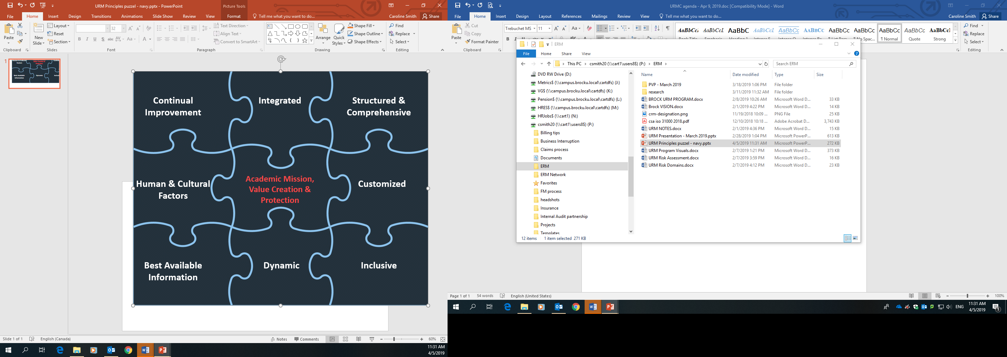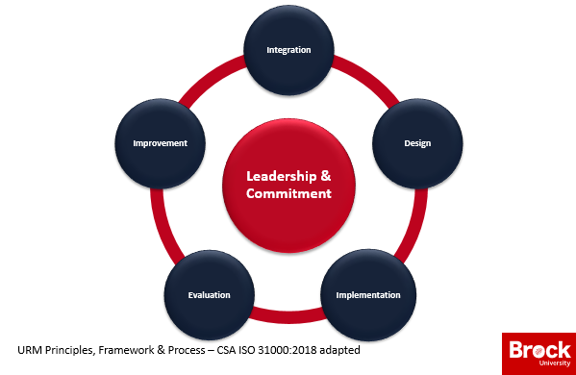

URM Process

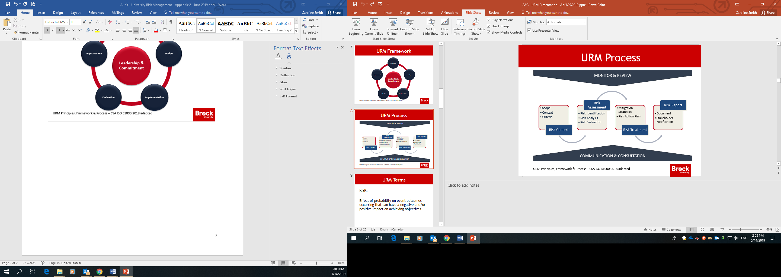

Adapted to be a consultative resource and tool to assist the University community with risk management integrated into planning and decision making processes. The URM philosophy fosters a culture that is risk-aware without being risk-averse.

The URM Program is tailored to ensure risks are identified, assessed and managed appropriately in order for University stakeholders to make informed decisions optimizing on and recognizing that the University environment is unique and complex with multiple missions and objectives. Developed with International and Canadian Standards for Risk management and best practice in the University sector in mind, the University will be further equipped and supported to identify and manage risk and/or seek to optimize risk opportunities in order to achieve the University’s academic mission, strategic priorities and goals.

Have questions or concerns?
Be Safe besafe@brocku.ca or ext. 7233
Caroline Smith, University Risk Management Manager csmith20@brocku.ca or ext. 4763

Health, Safety & Wellness Contacts
Be Safe besafe@brocku.ca or ext. 7233
Wellness wellnessday@brocku.ca
Leigh Harold, Director, Health, Safety & Wellness lharold@brocku.ca or ext. 3123
Kathryn Walker, Manager, Health Management & Wellness kwalker6@brocku.ca or ext. 6086
Caroline Smith, University Risk Management Manager csmith20@brocku.ca or ext. 4763
Jennifer Booker, Environmental Health & Safety Specialist jbooker@brocku.ca or ext. 5390
Brian Dzurban, Occupational Health & Safety Specialist bdzurban@brocku.ca or ext. 3284
Dan Pozzobon, Occupational Health & Safety Specialist dpozzobon@brocku.ca or ext. 5994
Cara Kirkham, Health Management Consultant ckirkham@brocku.ca or ext. 4237
Leila Vistorte, Lab Safety Specialist lvistorte@brocku.ca or ext. 6179

