There are 27 areas with campus bulletin boards located across campus.
Only ONE poster per service, initiative, activity, or event can be posted in each area at a time, regardless of the number of physical boards in that area.
Area 1 | Schmon Tower  Between Tim Hortons and MacKenzie Chown stairs | 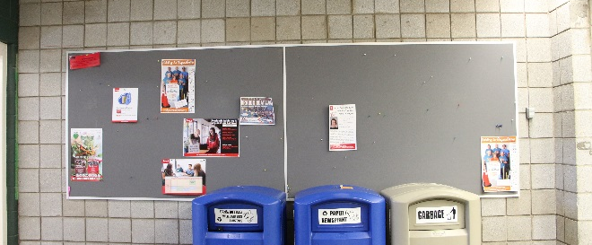
Area 2 | Thistle  Across from room TH 259 | 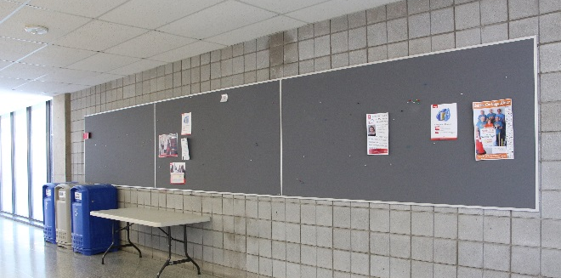
Area 3 | Thistle  Across from TH 245 | 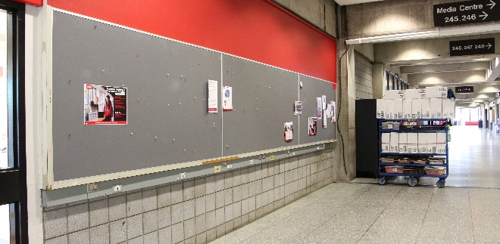
Area 4 | Thistle  Next to TH 247 | 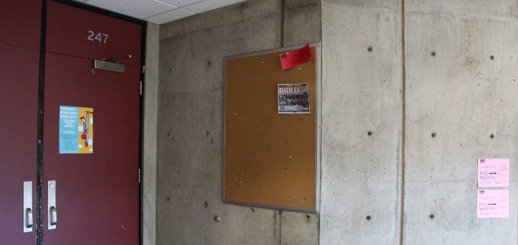
Area 5 | Scotiabank Hall  Just past entrance to/from Thistle | 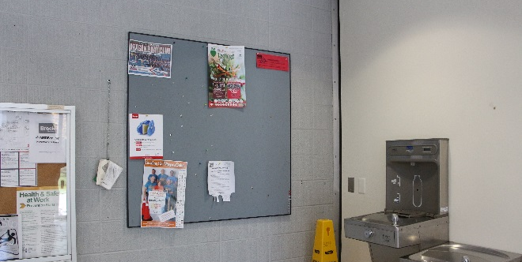
Area 6 | Scotiabank Hall  Outside washrooms, near Fishbowl (Computer Commons) | 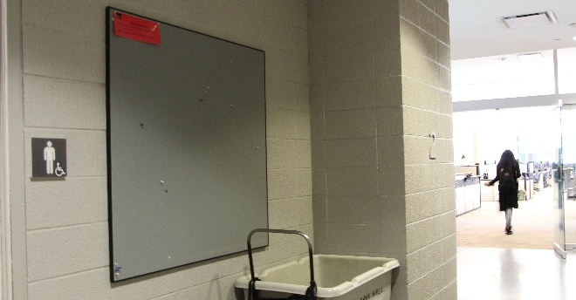
Area 7 | Welch Hall  Outside General Brock  (3 boards) | 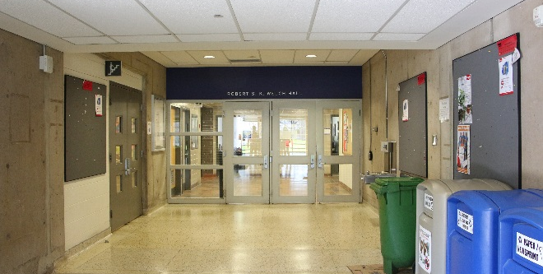
Area 8 | South Block  Top of ramp, around the corner from General Brock | 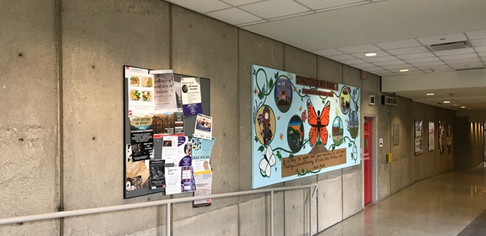
Area 9 | South Block  Bottom of ramp | 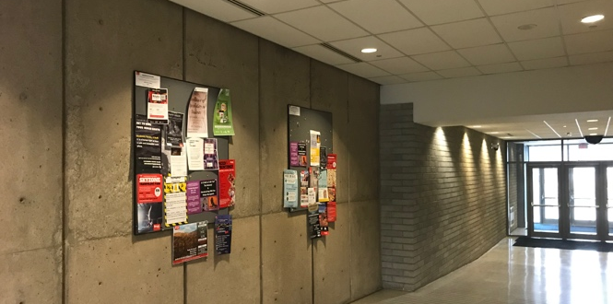
Area 10 | South Block  Around corner from AS 217 | 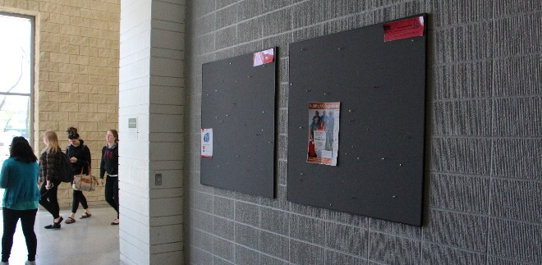
Area 11 | South Block  Pole at top of ramp, near Hungry Badger | 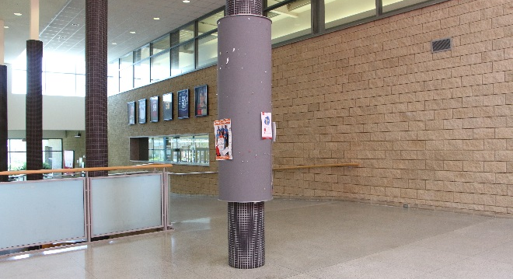
Area 12 | South Block  Just past AS 204, across from Hungry Badger  (3 boards) | 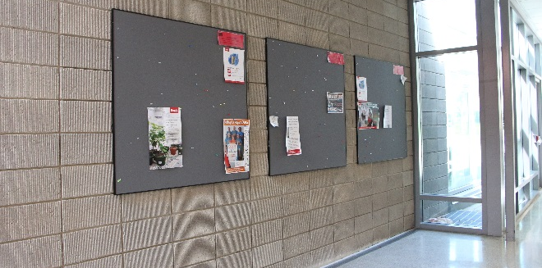
Area 13 | Walker Complex  Near entrance from South Block, above gyms  (3 boards) | 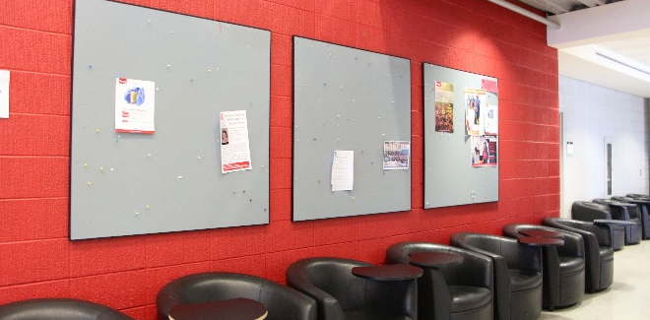
Area 14 | Walker Complex / Scotiabank Hall  Hallways towards Walker, past Fishbowl Computer Commons  (3 boards) | 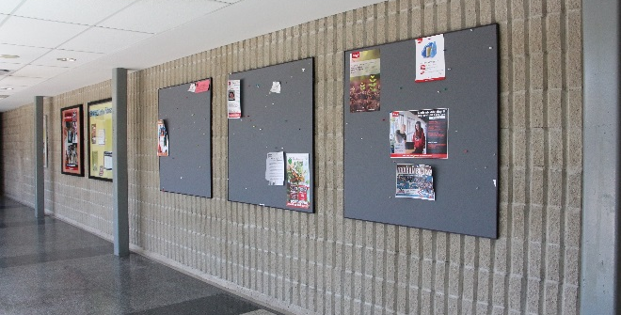
Area 15 | Mackenzie Chown  B-block, 300 level, near entrance from A-Block | 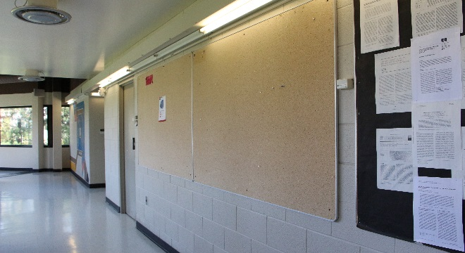
Area 16 | Mackenzie Chown  B-block, 300 level, near elevator | 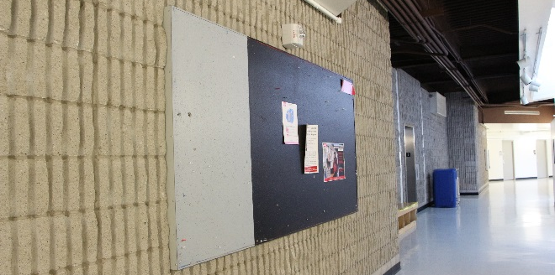
Area 17 | Mackenzie Chown  C-block, 300 level, just before entering D-Block | 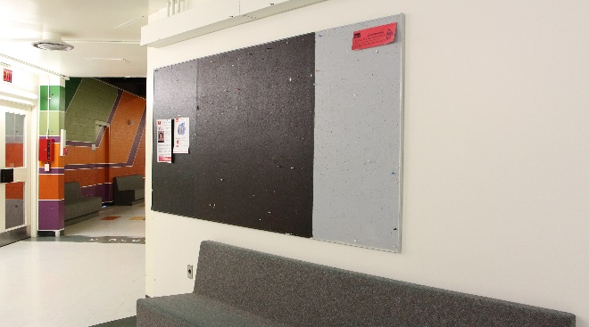
Area 18 | Mackenzie Chown  D-block, 300 level, just before entering J-Block, near elevator | 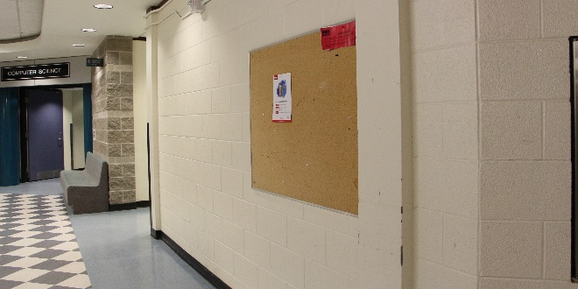
Area 19 | Mackenzie Chown  J-block, 200 level, across from washrooms | 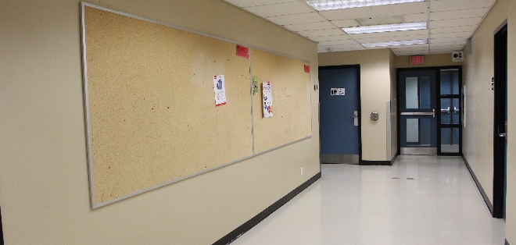
Area 20 | Mackenzie Chown  H-block, 300 level, near MCH 303  (4 boards) | 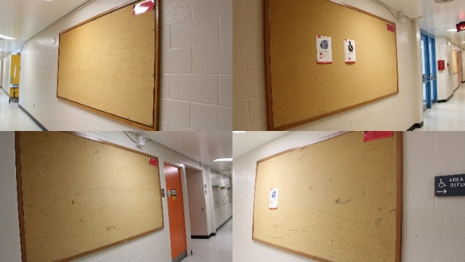
Area 21 | Plaza  200 level, near elevator entering Union Station top of ramp to/from Campus Store | 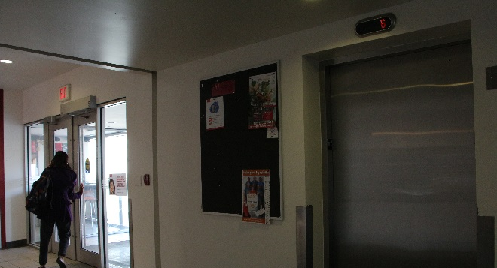
Area 22 | Plaza  200 level, top of ramp to/from Campus Store | 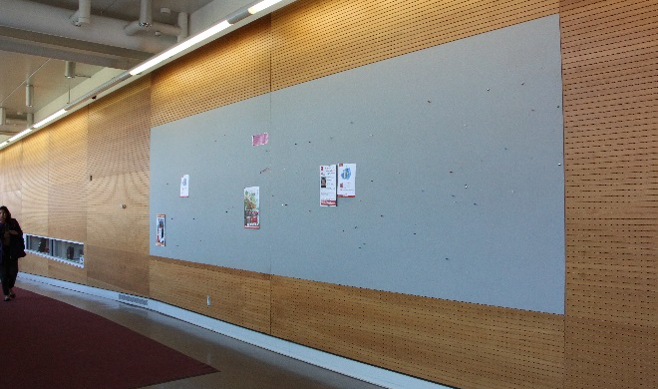
Area 23 | Plaza  300 level, outside classrooms | 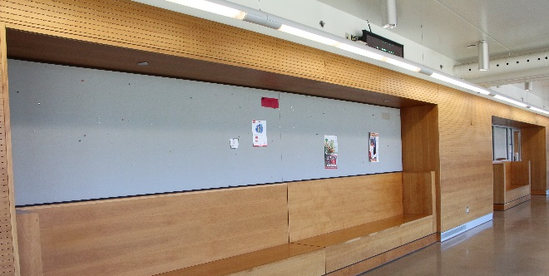
Area 24 | Plaza  400 level, outside classrooms | 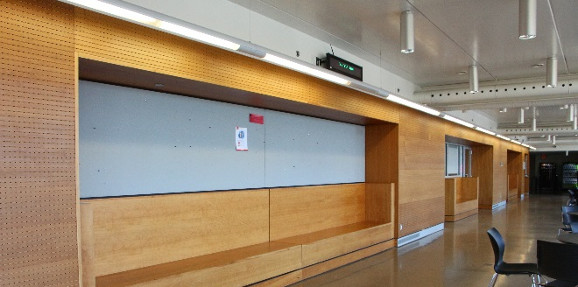
Area 25 | International Centre, 573B Glenridge Ave  On wall between dining area and lounge area | 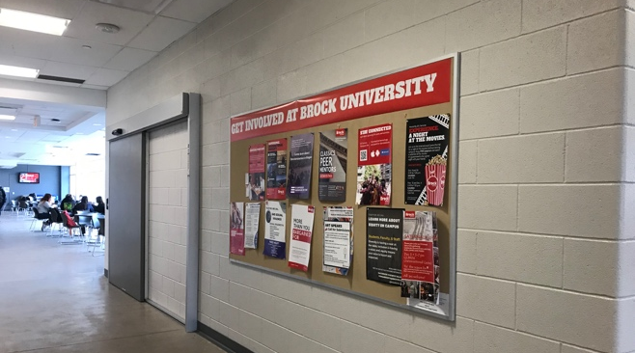
Area 26 | International Centre, 573B Glenridge Ave  To the left of classroom 121 | 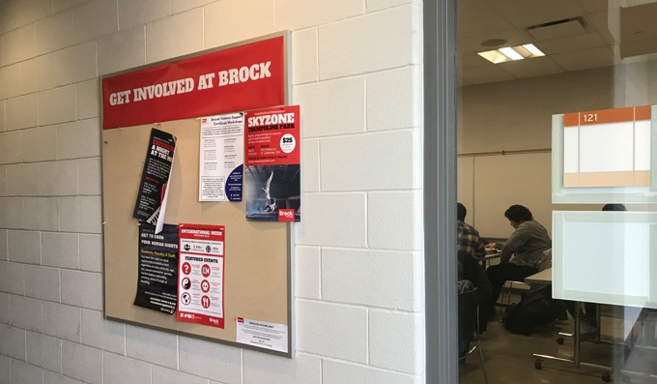
Area 27 | International Centre, 573B Glenridge Ave  near exit doors (Towards Niagara Children’s Centre) across from lounge area | 