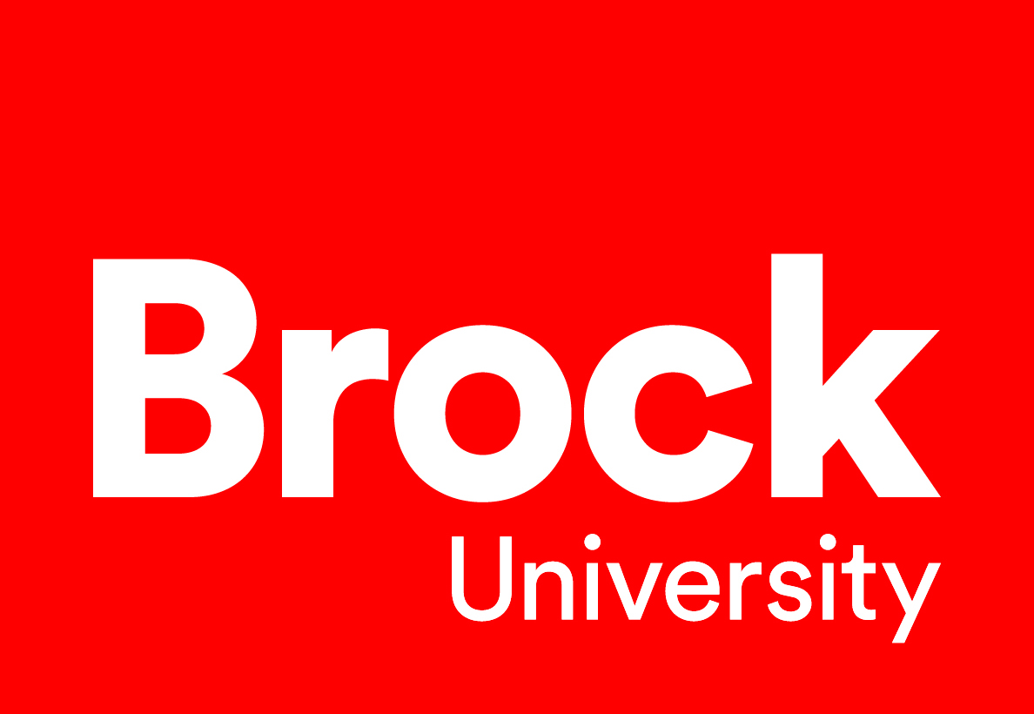
ISPAC Meeting
Agenda
April 22, 2026 10:30 am – 12:30pm | RFP 216 & Teams
- Opening & Welcome (Jeannie)
Roundtable of Introductions (Jeannie)

- Words from the Provost (Arja Vainio Mattila) (Joining from 10:30-11:30)
- Review last meetings minutes

- Update on where we are at: (Sheila)
  - Staff Consultations Integration - completed
  - Community Consultations - completed
  - Qualtrics Survey – completed

- What needs to be done (Sheila)
  - Consultant Work to begin
  - Analysis and Synthesis of all consultations into draft themes
  - Draft Strategic Plan

- Timeline Additions (ALL)
  - Consultant workflow
  - Marketing & Communications
    - Jenny Tilbrook & Tiegan McIntyre to join May 27th meeting

- Update to the participants who took part in the Consultations

- Other Items (All)

- Next Meeting & Closing (Jeannie)

  - Next meeting is on May 27, 2026
  - Closing

