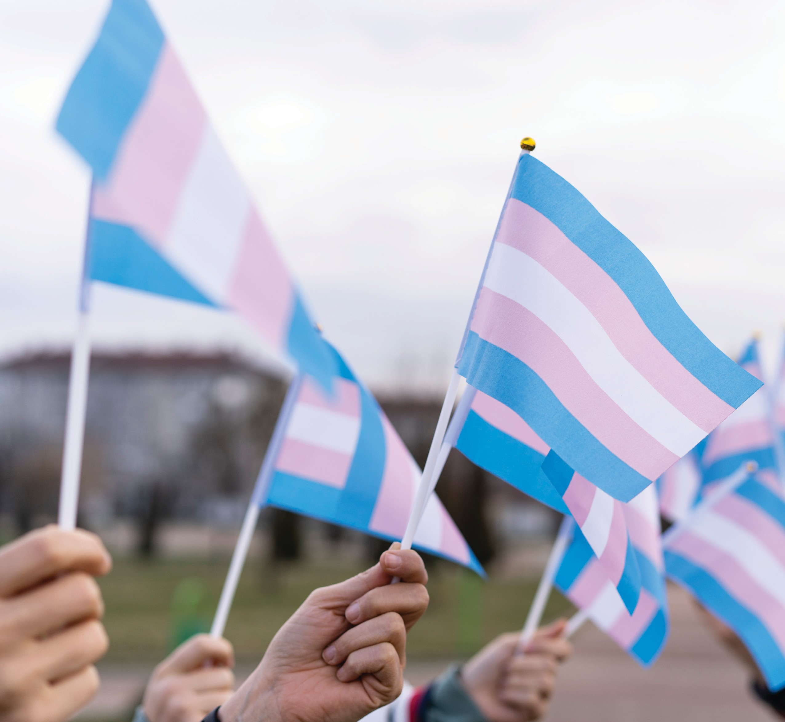


Transgender-Inclusion Guide
Last revised 2024

Contents
Acknowledgements 4
Land Acknowledgement 4
Disclaimer 4
Introduction 5
All Gender Washrooms 6
Brock Sports and Recreation 2
Brock Sports 2
Brock Recreation 3
Gender on Forms 3
Programming 3
Washrooms and Locker Rooms 3
Emergency Services 4
Emergency Student Loan Program (ESLP) 4
Food First 4
Emergency/Temporary Housing 5
Gender Affirmation Fund (GAF) 5
Employees who are Trans or Transitioning at Brock 5
Green Shield Gender Affirmation Benefits Coverage 5
The Office of People & Culture 5
Harassment, Discrimination, and Sexual Violence Complaints 6
Health Benefits Coverage for Trans-Specific Healthcare 7
Brock University Students’ Union (Full-time undergraduate students) 7
Brock University Students’ Union (Part-time undergraduate students) 7
Brock University Graduate Students’ Association (GSA) 7
CUPE 4207 (Green Shield Canada) 8
Ontario Drug Benefit Coverage (ODB) 8
Ontario Health Insurance Plan (OHIP+) 8
University Health Insurance Plan (International Students) 8
Name and/or Gender Marker Change on Student Records and Transcripts 9
Office of the Registrar and Enrolment Services 9
Name Change Request Forms 9
Request for Change of Students’ Chosen Name on Brock Systems 9
Requests to Change Students’ Legal Names on Academic Records 10
Documents, Examinations, Transcripts, and Diplomas 10
Off-Campus Trans, Nonbinary, and Two-Spirit Groups and Supports 11
Trans Lifeline 11
Quest Community Health Centre 11
Niagara Falls Community Health Centre 13
Positive Living Niagara 13
OUTNiagara 14
Transgender Niagara 14
Niagara Transgender Action Coalition 15
PFLAG Niagara 15
LGBT Youthline 16
On-Campus Trans, Nonbinary, and Two-Spirit Groups and Supports 16
Human Rights and Equity Office 16
Student Justice Centre (SJC) 17
Services 17
Brock Pride 18
Ontario Public Interest Research Group Brock (OPIRG) 18
Hadiyaˀdagénhahs First Nations, Métis and Inuit Student Centre 19
Services 19
Pronouns 20
Research Ethics and the Collection of Data 20
On-Campus Housing (Residence and Brock Suites) Information 21
Seeking Accommodations 21
Housing Application Process 21
Room Switch Requests 22
Washrooms 22
The Two-Spirit, LGBTQIA+ and Allies Living Learning Community (LLC) 22
Student Accounts and Financial Aid 22
Wellness, Accessibility, and Health Services 23
Student Wellness and Accessibility Centre 23
Employee and Family Assistance Program 24
Canadian Mental Health Association (CMHA): Niagara 24
Closing Statement 24

Acknowledgements
We would like to express our deepest appreciation to the Trans-Inclusion Project student assistants Jasper Fisher and Max Hunter for researching and authoring this resource with funding from Canada Summer Jobs in 2019, with additional thanks to Jasper Fisher for reviewing and updating this document in the summer of 2022. We would also like to thank Leela MadhavaRau, Michelle Poirier, Shannon Kitchings, and the rest of Brock’s Human Rights and Equity Office for spearheading this project. Furthermore, we would like to acknowledge all the transgender, nonbinary, genderqueer, and Two-Spirit people who helped in the development of this guide. Without the support of these people and countless others from the Brock community, this project would not have been possible.

Land Acknowledgement
Brock University acknowledges the land on which we gather is the traditional territory of the Haudenosaunee and Anishinaabe peoples, many of whom continue to live and work here today.
This territory is covered by the Upper Canada Treaties and is within the land protected by the Dish with One Spoon Wampum Agreement, an agreement representing that this land is to be shared peacefully.
Today this gathering place is home to many First Nations, Métis and Inuit peoples and acknowledging reminds us that our great standard of living is directly related to the resources and friendship of Indigenous people.

Disclaimer
The information included in this document is intended to be used as a resource for Brock University students, staff, faculty, and visitors in navigating transgender, nonbinary, and Two-Spirit related matters in the university environment. All information included in this resource is accurate at the time of its last update (May 2024), however, as much of this material may be subject to change over time, please take the appropriate steps to ensure that all information is entirely correct.
If you notice any inaccuracies or broken links while utilizing this resource, please inform the office of Human Rights and Equity at humanrights@brocku.ca so that we are able to maintain the accuracy of this document.

Introduction
Harassment and discrimination on the basis of gender identity or gender expression are violations of the Ontario Human Rights Code and Brock’s Discrimination and Harassment Policy. All people who are transgender, nonbinary, Two-Spirit, and/or gender diverse are legally protected under the Ontario Human Rights Code on the ground of gender identity/gender expression and under Bill C-16 and the Canadian Human Rights Act. At Brock University, all students, staff, faculty, and visitors have the right to be treated equally and equitably with dignity and respect in the classroom, workplace, and University affiliated locations or events. This document aims to provide information about resources, procedures, accessibility issues, and concerns related to gender identity and expression to ensure all members of the University community have the information necessary to create an inclusive environment for all.
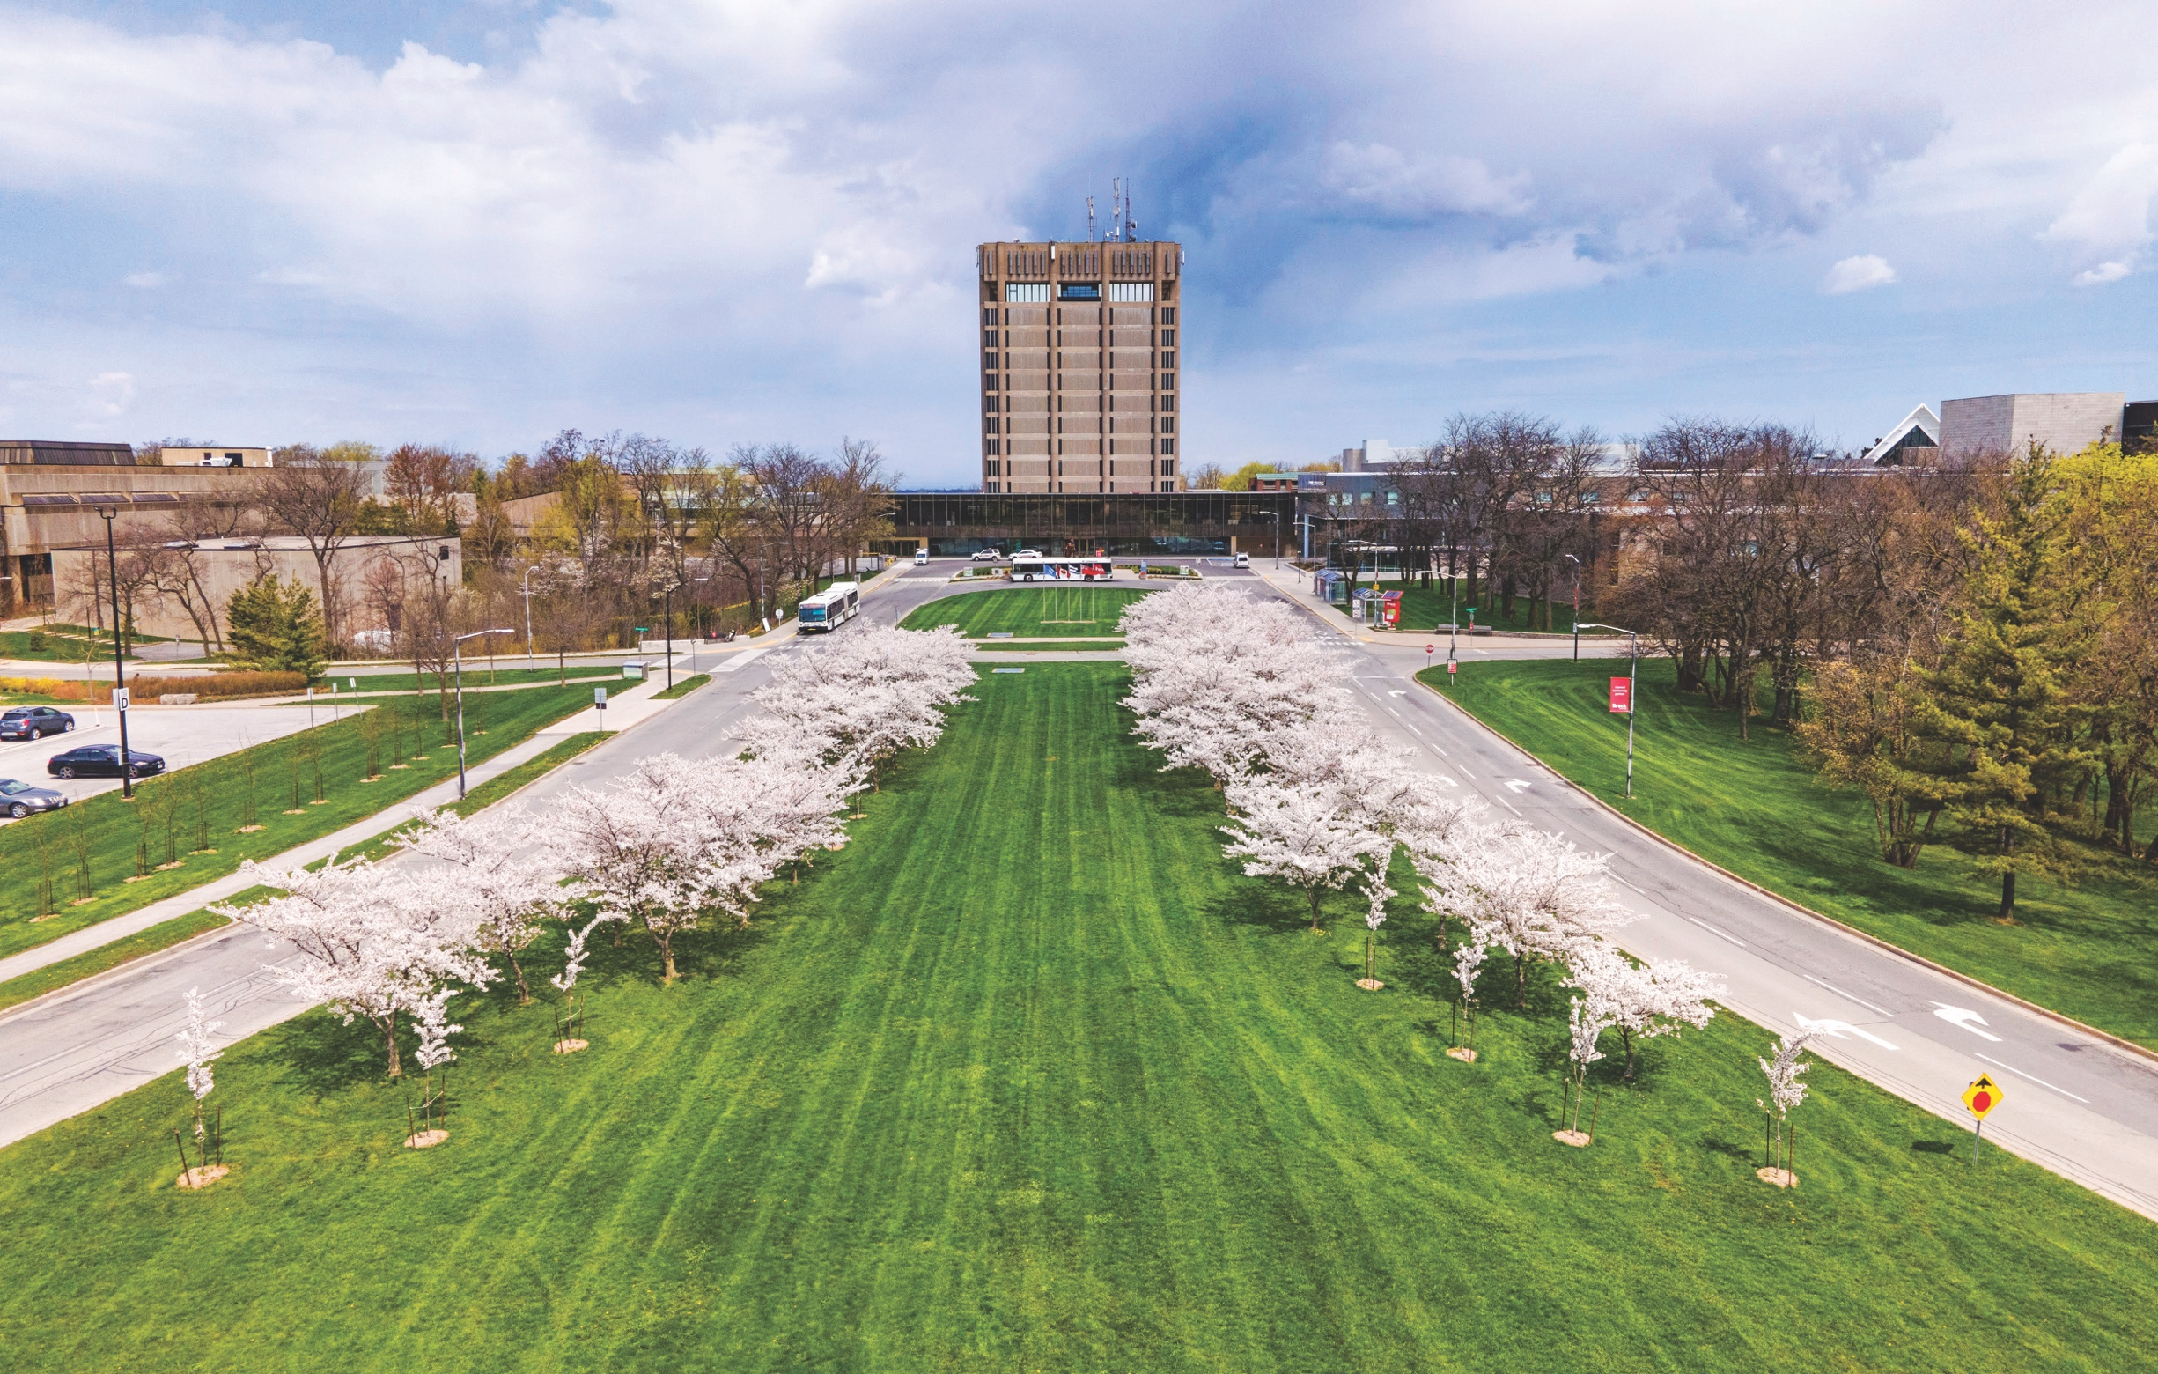

All Gender Washrooms
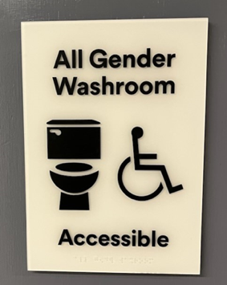
Brock University is currently in the process of converting a number of its single-user washrooms into All-Gender washrooms to increase the gender accessibility of the institution. At present, the institution has around 50 All-Gender washrooms on its campuses. These are identifiable by the image shown to the left, which is displayed on the doors of all gender washrooms. These washrooms will provide more options for students, staff, faculty, and visitors who do not prefer, or cannot, use binary-gendered spaces. See below for a list of the All Gender washrooms on campus:

No. | Area | Washroom description | Location
1 | AL | Washroom-All-Gender | 103
2 | GSBB | Washroom-All-Gender | 275A
3 | GSB | Washroom-All-Gender | 275B
4 | CRN | Washroom-All-Gender | 356
5 | CRN | Washroom-All-Gender | 404
6 | CRN | Washroom-All-Gender | 405
7 | CRN | Washroom-All-Gender | 504
8 | CRN | Washroom-All-Gender | 505
9 | GSB | Washroom-All-Gender | 415A
10 | GSB | Washroom-All-Gender | 415B
11 | HH | Washroom-All-Gender | 119
12 | KC | Washroom-All-Gender | 109A
13 | KC | Washroom-All-Gender | 109B
14 | MCJ | Washroom-All-Gender | J208
15 | PLZ | Washroom-All-Gender | 305
16 | PLZ | Washroom-All-Gender | 405
17 | PLZ | Washroom-All-Gender | 500H
18 | PLZ | Washroom-All-Gender | 600D
19 | PLZ | Washroom-All-Gender | 623*
20 | WC-A | Washroom-All-Gender | 146A
21 | WC-A | Washroom-All-Gender | 150A
22 | WH | Washroom-All-Gender | 100B
23 | HAM | Washroom-All-Gender | 28
24 | MWS | Washroom-All-Gender | 220
25 | MWS | Washroom-All-Gender | 318
26 | MWS | Washroom-All-Gender | 410
27 | ST | Washroom-All-Gender | 410

No. | Area | Washroom description | Location
28 | ST | Washroom-All-Gender | 204
29 | CRN | Washroom-All-Gender | 106
30 | CRN | Washroom-All-Gender | 107
31 | CRN | Washroom-All-Gender | 356
32 | HH | Washroom-All-Gender | 118
33 | HH | Washroom-All-Gender | 126
34 | SC | Washroom-All-Gender | 305
35 | SC | Washroom-All-Gender | 306
36 | SH | Washroom-All-Gender | 202
37 | ST | Washroom-All-Gender | 523
38 | TH | Washroom-All-Gender | 125A
39 | TH | Washroom-All-Gender | 222C
40 | WH | Washroom-All-Gender | 361
41 | WH | Washroom-All-Gender | 263
42 | WH | Washroom-All-Gender | 19
43 | CJD | Washroom-All-Gender | 117F
44 | HAM | Washroom-All-Gender | 13D
45 | HAM | Washroom-All-Gender | 41B
46 | MWS | Washroom-All-Gender | 222
47 | MWS | Washroom-All-Gender | 320
48 | MWS | Washroom-All-Gender | 322
49 | MWS | Washroom-All-Gender | 412
50 | MWS | Washroom-All-Gender | 414
51 | RFP | Washroom-All-Gender | 311A
52 | RFP | Washroom-All-Gender | 311B
53 | MCA | Washroom-All-Gender | A334

Brock University also provides a Family/Universal change room for athletics and recreation which includes 8 large closed changing stalls, a semi-private shower, and two All-Gender washrooms, one of which is accessible.

Brock Sports and Recreation
Brock Sports and Recreation encompasses sports, recreation and activities ranging from elite varsity competitive programs, intramural sports of a variety of levels, to drop in recreation opportunities. Numerous classes, courses, events, camps, and programs are available to students, faculty, staff and community members.
Brock Sports and Recreation offers various types of leagues including:
- Women’s (inclusive of transgender, feminine-aligned, and cisgender women)
- Men’s (inclusive of transgender, masculine-aligned, and cisgender men)
- Co-rec (open and accessible to all genders and expressions)

Brock Sports
Varsity Teams are currently divided into:
- Men’s teams
Women’s teams
Registration for Brock Sports is processed using a number of programs, and some coaches may track using systems not identified in this document.
The Ontario University Athletics (OUA) has an inclusive policy that allows transgender athletes to compete on the varsity team that corresponds with their gender identity. Athletes do not need to be on hormones or have any surgeries to compete on a gendered team. The only restriction is that the athlete may only compete on sport teams of one gender during a given academic year (i.e. the athlete cannot switch to a different gendered team mid-season).
USports (Canadian University Sports) adopted the following policy in 2018:
80.80.5 TRANSGENDER STUDENT-ATHLETES
80.80.5.1 This Policy 80.80.5 governs the eligibility of transgender student-athletes in U SPORTS competition.
80.80.5.2 Student-athletes may not exceed five (5) years of participation in total (including any time in either male or female U SPORTS competition) as per policy 40.10.4.3.1.1.
80.80.5.3 Subject to Policy 80.80.5.4 below, student-athletes may compete on the sport team that corresponds with either their sex assigned at birth or their gender identity, provided that at all times student-athletes are in compliance with the Canadian Anti-Doping Program.
80.80.5.4 Student-athletes may only compete on sport teams of one gender during a given Academic Year (as defined in 40.10.3.1.1).
This policy permits a student-athlete to compete on a sport team that corresponds with either their gender identity or their sex assigned at birth. Student-athletes are required to comply with the Canadian Anti-Doping Program (CADP), however the approved policy does not require that transgender student-athletes undertake any form of medical intervention or gender affirming care in order to compete. This is a significant difference between U SPORTS’ policy and many other national and international governing body policies.
For more information, please contact:
Emily Allan, Associate Director, Brock Sports eallan@brocku.ca

Brock Recreation

Gender on Forms
Brock Recreation receives most of their demographic information from Brock’s Registrar’s Office, and new accounts created for students all begin with “other” indicated for gender. Recreation does not require you to disclose your gender on membership forms, although anybody using the Walker Sports Complex may choose Male (M), Female (F), or Other as their gender marker. When registering for classes, intramural sports, or varsity sports, however, binary gender markers (Male/Female) are often required. These forms come from an external source and are currently under review to increase inclusivity. Registration for Intramural Sports Teams is processed by IMLeagues, a third party external to Brock University. IMLeagues provides a limited selection of gender identity options, which adheres to the Male/Female binary.

Programming
Most fitness classes and programs offered through Brock Recreation are not restricted by gender, with the exception of “Women’s Only Hours” at the Zone Fitness Centre including programs happening in the Zone during Women’s Only Hours. Women’s only hours provide a safe, comfortable, inclusive and fun atmosphere for anyone at Brock University who identifies as a woman (“women” includes all cis and trans individuals who identify as a woman).
Currently, there are no gendered swim times, meaning any person of any gender identity may participate. If a need for gendered swim times arises, Brock Recreation is open to creating a dedicated time should interest be expressed (these gendered swim times would be inclusive of transgender/nonbinary/Two-Spirit people).

Washrooms and Locker Rooms
The current options for locker rooms in the Walker Complex are:
- Female-Identified locker room – 1st floor, connected to the pool.
Includes open-design locker room, open and semi-private showers, washrooms, lockers (long/short term rentals).
- Male-Identified locker room –1st floor, connected to the pool.
Includes open-design locker room, open and semi-private showers, washrooms, lockers (long/short term rentals).
- Family/Universal locker room –1st floor, connected to the pool.
Includes 8 large, closed changing stalls, semi-private shower, two All Gender washrooms (one is accessible), lockers (single-use rental).
For more information, contact:
Karen McAllister-Kenny – Director, Brock Recreation kmcallisterkenn@brocku.ca

Emergency Services
Below are the emergency services offered at Brock University for students that have encountered sudden financial issues, food insecurities and housing insecurities. This section is included in the Trans-Inclusion Guide because trans and gender diverse people may experience systematic oppression, harassment and discrimination, and family/peer support issues in relation to one’s gender identity and may require access to emergency services in a safe environment.

Emergency Student Loan Program (ESLP)
Brock University Students’ Union (BUSU) and Student Accounts and Financial Aid (SAFA) offer an emergency bursary available for students who are experiencing short-term financial difficulties. Common reasons for this loan are delays in Ontario Student Assistance Program (OSAP) funding, unexpected expenses, or sudden loss of income.
The ESLP is limited to Brock students currently enrolled in at least one undergraduate or teacher education course (as through this, they are paying into BUSU-administered course fees). There are restrictions on who can receive an emergency bursary, so please check here (under the “Student Loans” tab) for more information.
Students can request up to $500.00 from the ESLP at any one time and are able to receive a maximum of 5 loans throughout their undergraduate degree. Successful applicants will be given a cheque written in the current legal name of the applicant.
To apply for an ESLP, fill out Brock’s OneApp through your my.brocku.ca portal.

Food First
Brock University Students’ Union (BUSU) offers a free food program to mainly undergraduate students in need of food due to food insecurities or financial situations. In person, this program is currently limited to products that have a longer “shelf life.” There is ongoing work to implement a produce delivery service. In addition, packages of non-perishable food, hygiene products, and gift cards to local grocery stores are provided to those in need. For more information, check out Food First’s Brock webpage here, or contact foodfirst@brockbusu.ca.
For students in need, individuals can also fill out a form here to receive, in good faith, a gift card to a local grocery store through the program. This service is designed to assist with food and health accessibility and is not intended to be a primary source of food for any one undergraduate or graduate student. Program requests are reviewed every Friday from 12:00 pm to 6:00 pm. The gift card will be given out electronically, if eligible. The form allows for students to provide either a legal or a preferred name, as well as their student number and student email.

Emergency/Temporary Housing
Depending on availability, the Department of Residences may be able to provide emergency or temporary housing. If the need is urgent (housing required immediately), please contact the North Service Desk at 905-688-5550 x3370 or res@brocku.ca to inquire about availability.

Gender Affirmation Fund (GAF)
In early 2023, Brock’s Human Rights and Equity Office introduced the Gender Affirmation Fund (GAF). The GAF is a form of prompt financial support for Brock community members who self-identify as Two-Spirit, transgender, nonbinary, and/or gender diverse/nonconforming to assist with the costs associated with various aspects of affirming one’s gender. Recognizing that experiences of affirming one’s gender and of being Two-Spirit, transgender, non-binary, and/or gender nonconforming are diverse and can impact many aspects of one’s life, the GAF intentionally does not outline all eligible expenses. The only requirement is that the costs for which one is applying for the GAF are acquired for the purpose of affirming their gender, in whichever way they choose.
The GAF is allocated $10,000 per funding year (April 1 to March 31). There is a $1500/funding year cap and a $4500 lifetime cap per applicant. Applications are assessed monthly and monthly deadlines are the 1st of each month at 12:00 am. Learn more about the GAF and/or access the application here.

Employees who are Trans or Transitioning at Brock

Green Shield Gender Affirmation Benefits Coverage
Brock’s support for the health and well-being of trans and non-binary employees recently expanded with the addition of gender affirmation benefits coverage provided by Green Shield Canada. The offering was developed by Green Shield in consultation with a number of organizations, including the Canadian Professional Association for Transgender Health (CPATH) and the World Professional Association of Transgender Health (WPATH), and is designed to help fill gaps tied to services not covered by provincial and territorial government health-care plans. Employees eligible for Brock’s extended health and dental benefits through Green Shield can obtain further information on the Brock University benefit SharePoint site, and Green Shield representatives are available to answer any questions members may have regarding coverage.

The Office of People & Culture
The Workday system currently has options for both a legal and a chosen name. Employees do not have to provide legal documentation to add a chosen name in the Workday HR system. To do this, follow these steps:
- Log in to your Workday HR account through the My.BrockU.ca portal,
- Select the profile icon in the top right corner, then view profile,
- Select “Personal” on the far-left menu,
- Select “Names” on the top menu,
- Add your chosen name.
To change your legal name, you must visit the office of People & Culture office with the document indicating your legal name change (for Canadian citizens, this is the Change of Name Certificate) and one piece of government issued photo ID that reflects your new name. Staff will take copies of these documents and change the information in your file. New employees must sign contracts and other supporting documents with a current legal name, which matches your direct deposit bank statements. Before you update a legally changed name in the Brock systems, you must first update your personal banking information to reflect your new name.
A legal gender change can also be brought with supporting documents to the People & Culture office to be changed in your employee records. For administering health, long-term disability, and life insurance benefits, the People & Culture Office must collect a legal sex designation, however, if your gender marker has not been changed, you may still indicate which honorific you wish to be referred to as. You may change this on Workday by following the same steps listed above for a chosen name, or by visiting the People & Culture Office in person and indicating that you wish to change what you are addressed as on documents. At present, Workday unfortunately does not presently offer titles such as Mx., however work is being done to create new options. If you have other choices you would like included, please notify Human Rights and Equity.

Harassment, Discrimination, and Sexual Violence Complaints
Brock University is committed to building and maintaining a diverse and inclusive community where our students, staff, and faculty can work and learn in an environment that respects the dignity and worth of all members of the Brock community. The Discrimination and Harassment Policy (DHP) addresses instances when harassment, and/or discrimination occurs.
The DHP process is invoked when a Brock community member makes a complaint or report of conduct that violates the DHP. Staff in the Human Rights and Equity office will work confidentially with parties to resolve the complaint through one of three levels of resolution: Personal Resolution, Informal Resolution, or Formal Resolution. A full explanation of the DHP process is available to members of the Brock community here (the policy alone) or here (under Human Rights and Equity Policies).
Furthermore, Brock University unequivocally prohibits and will not condone, tolerate, or ignore any form of sexual violence that affects the work and learning environment at the university. The university recognizes that sexual violence can have serious and lasting effects on the physical, mental, and emotional welfare of survivors. The university provides access to supports, services, and appropriate accommodation for any Brock community members who are affected by sexual violence through the Human Rights and Equity office. A full explanation of Brock’s Sexual Assault and Harassment Policy can be found here.
To report an incident of harassment, discrimination, or sexual violence, please contact the office of Human Rights and Equity, or fill out the intake form here to make a disclosure. For gender and sexual violence, please visit this page for options for disclosure and support information, or contact svsec@brocku.ca.

Health Benefits Coverage for Trans-Specific Healthcare
The following section is provided for general information purposes only. Please contact the specific benefits provider you are using directly for the most accurate coverage information.

Brock University Students’ Union (Full-time undergraduate students)
Hormones are covered by the BUSU health plan when proper documentation is provided (as with any other prescription). Most application methods (i.e., injection, gel, capsules, patches, etc.) for hormones are accepted, and specific prescriptions can be verified for drug coverage here. The BUSU health plan also covers most forms of medical contraceptives, available to people of any gender identity. For inquiries, contact healthplan@brockbusu.ca or (905) 688-5550 x4194.
Gender affirming surgeries are not covered under this plan.
Note: An undergraduate student must be enrolled in a minimum of 3.0 undergraduate credits for the academic year (September to April), by the fall deadline (September 30th) to be eligible for coverage under the BUSU health plan.
For more information, please visit www.studentvip.ca.

Brock University Students’ Union (Part-time undergraduate students)
Currently, undergraduate students enrolled in fewer than 3.0 undergraduate credits for the academic year (September to April) are not covered by the BUSU health plan.
Note: There may be exceptions to eligibility criteria for international/exchange students, students that are registered with the Student Development Centre as a student with a disability, and students who are in their final year of study. For questions about eligibility, please contact healthplan@brockbusu.ca or (905)-688-5550 (x4194).

Brock University Graduate Students’ Association (GSA)
Hormones are covered by the GSA health plan when proper documentation is provided. Please note that at the time of research, only two types of estrogen Hormone Replacement Therapy (HRT) are eligible for coverage (most forms of testosterone are covered). Please check here to search for specific up-to-date hormone coverage. The GSA health plan also covers most forms of medical contraceptives, available to people of any gender identity. For inquiries, contact gsahealth@brocku.ca.
Gender affirming surgeries are not covered under this plan.

CUPE 4207 (Green Shield Canada)
The CUPE health and dental insurance plan is provided through Green Shield Canada which covers hormones. Most forms of estrogen and testosterone are eligible for coverage provided the claimant meets the standard criteria for eligibility. Staff and faculty can choose from several coverage options: Single Coverage, Couple Coverage, or Family Coverage. Under the Couple or Family coverage plans, dependants may also be eligible for hormone coverage.
Gender affirming surgeries are mostly covered under this plan.
For more information, visit here.

Ontario Drug Benefit Coverage (ODB)
If you are eligible for Ontario Drug Benefit (ODB) Coverage, most methods for HRT are partially or fully covered. Please check here, where you can search for specific hormones and application methods for coverage.

Ontario Health Insurance Plan (OHIP+)
If you are eligible for the Ontario Health Insurance Plan (OHIP+), most methods for HRT are partially or fully covered. OHIP+ is available for people who are under 24 years old, and only requires a prescription and a valid Ontario Health Card. Please check here for specific drug coverage.
Most Gender-Affirming Surgeries are covered under OHIP, including both chest and genital surgeries. Please check here for details on what is needed for approval of these surgeries, and note that wait times are typically quite lengthy when applying through OHIP. NOTE: Surgeries that are defined as “cosmetic” are not currently applicable for OHIP coverage. The criteria for surgical coverages are currently being updated, so please check the above hyperlink for the most up-to-date information.

University Health Insurance Plan (International Students)
UHIP works in combination with the Student VIP (BUSU) health plan to ensure coverage is as well-rounded as possible. International students are automatically enrolled in UHIP. This plan does not cover prescriptions, as these are supplemented by the BUSU health plan.
Some Gender-Affirming Surgeries are covered under UHIP. Please check here for details on approval and criteria.

Name and/or Gender Marker Change on Student Records and Transcripts

Office of the Registrar and Enrolment Services
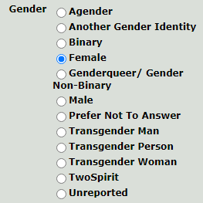
Gender is required to be filled in on Brock Internal Applications as well as those through the Ontario Universities’ Application Centre (OUAC). Options to indicate gender have been updated to be more inclusive (see below). For those not wanting to report there is the option ‘unreported’ that they may select.
Students may request a gender change without legal documentation, which would be completed on an individual basis through the Office of the Registrar and Enrolment Services. Students are welcome to contact Academic Records at records@brocku.ca, or the Associate Director, Data, Records & Space Management (x3099) to set up a meeting to complete the next steps of the process, depending on the individual’s requests. The Office of the Registrar and Enrolment Services and Enrolment Services is a confidential space, and people accessing the services of the Registrar’s Office may request to use a private meeting space without providing a reason if more privacy is desired. When visiting Brock Central – Office of the Registrar and Enrolment Services, people must put a name and phone number in an on-line queue, of which a chosen name can be used.
Incoming Students can choose which gender marker they include on OUAC or choose to omit it completely. This will then transfer into Brock University student records and does not require legal documentation.

Name Change Request Forms
In early 2023, Brock modified the process for students wishing to change their name, in effort to make it simpler and more accessible for trans, genderqueer, non-binary, and/or gender-nonconforming folks, and others who have this need. These changes include the creation of two new forms, described below:

Request for Change of Students’ Chosen Name on Brock Systems
The Request for Change of Students’ Chosen Name on Brock systems form, found here, does not require a legal name change. This form is for students who wish to change their name within Brock systems including: directory, student card, class list, Brightspace, student union, email alias, eRez, library, and parking services. Note that systems other than those listed above, including apps, department specific listings, etc. are not included, and will need to be updated by the student directly. Students can select to have their chosen name on their diploma when they apply to graduate.
Please note: Students who use their chosen name on their diploma can no longer use their diploma as a legal document.
Students legal name will be retained as part of the student’s permanent record and will be displayed on official transcripts. To have your name changed in these places, students must also complete the Requests to Change Students’ Legal Names on Academic Records form (below).
If you require a replacement student card as well, updated to show your chosen name, the Office of Human Rights and Equity will cover the cost of a replacement student card. Please email svsec@brocku.ca for more information about this process.

Requests to Change Students’ Legal Names on Academic Records
The Requests to Change Students’ Legal Names on Academic Records form, found here, is for students who have legally changed their name and would like their official records to reflect this. The name will appear on ALL official academic records and diplomas. Students must complete a legal name change before this form can be used, and must present TWO pieces of acceptable documentation, one of which must be photo ID that confirms the change you are requesting (e.g. changing your last name from Smith to Jones would require ID reflecting “Jones”).
For incoming students, OUAC has a field for indicating a “Commonly used” name for students to indicate what they prefer to be called, however they must also provide a legal name. This information will also carry into Brock records.

Documents, Examinations, Transcripts, and Diplomas
Documents that are Brock University issued may be signed using a chosen name, as long as student number is indicated somewhere on the document. This applies to examinations as well. Documents that are not Brock-issued, such as the Ontario Student Assistance Program (OSAP) or the Registered Education Savings Plan (RESP), must be signed in a current legal name.
When filling out an Intent to Graduate form, students are able to indicate what name they would like to have displayed on their diploma. Students can use a chosen name on a diploma, however this may lead to some unanticipated complications, such as discrepancies between legal documents and questions from future employers. It is important to meet with a Registrar’s Office representative to discuss the possibility of future issues.
Students who have already graduated that wish to have a reissue of their diploma in a different name may contact records@brocku.ca. As there is only one true parchment issued for each graduate, the reissued diploma will indicate that it is a duplicate diploma. A diploma reprint has an associated fee.

Off-Campus Trans, Nonbinary, and Two-Spirit Groups and Supports


Trans Lifeline
Trans Lifeline is a trans-led organization that connects trans people to the community, support, and resources that they need to survive. This service offers radical community care and trans peer support that is entirely divested from police, meaning there is absolutely no non-consensual police intervention. It is run for trans people, by trans people. Trans Lifeline offers an ID change library and service finder tools to help trans people access safe and accurate information and services. They also offer a hotline that individuals can call (in crisis or not), where you will speak to a trans/nonbinary peer operator with full anonymity and confidentiality if you need someone to talk to.
Trans Lifeline also offers Microgrants, which provide trans and nonbinary people with low-barrier funds and support to correct name and/or gender markers on legal ID, as well as provide financial and social support to incarcerated trans peers.
Contact Information
Canadian Hotline: (877) 330-6366

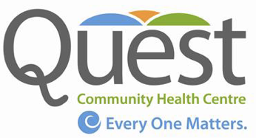
Quest Community Health Centre
Quest is a non-profit organization providing primary health care, health promotion, and community capacity building services. Their team consist of a wide range of interdisciplinary health care providers working in a shared care model that includes doctors, nurse practitioners, nurses, dietitians, health promoters, community outreach workers, outreach social workers, outreach nurses, therapists, and community health workers among other volunteer health professionals such as the staff dentist, dental hygienists, and dental assistants and chiropractors as well as learners from various disciplines.
Their focus is on the delivery of client-centred holistic health care that seeks to remove barriers to care as well as address the Social Determinants of Health. Special emphasis is placed on the following priority populations:
- Sexual and gender diverse populations (2S+LGBTQIA+) with a special emphasis on trans care;
- Individuals experiencing mental health, addictions, or concurrent disorders;
- Street-Involved populations (experiencing homelessness, under-housed, sex workers);
- At risk children, youth, and families;
- Isolated seniors;
- Individuals who frequent the emergency department for care/opioid dependency;
Migrant agricultural workers.
Quest CHC transgender-specific health care includes:
Doctors (trans and cis) specializing in trans health care;
Primary Health Care: assessment, diagnosis, treatment planning, prevention, health teaching, referrals, preventative health care;
Trans Specific health care: assessment, screening (Pap, PHE, etc.), diagnosis, initiation of hormone therapy, follow up, monitoring parameters, referrals, health teaching, imaging, lab work, treatment planning, injection teaching and access to supplies. Reproductive health care (e.g., sperm banking/egg harvesting), referrals to fertility clinics;
Chronic disease management- as part of general primary care as well as managing co-morbidities (e.g., diabetes, sleep apnea, mental health, fatty liver, and hormone therapy);
Assessment and referrals for gender confirming surgery: referral letters, OHIP approval navigation (form completion);
Post-surgical follow up: for both top and bottom surgeries, medication management, complication management, health teaching and support/coaching, pain management;
Support and care for gender independent children, youth and families: Education, support, assessment, health teaching, advocacy and follow up care, including leveraging school and home support as well as coverage for medication (e.g., E.A.P.);
Mental health support and counselling: individual and family support, assessment, diagnosis, therapy and general counselling;
Outreach support: general support and counselling, accompaniment, advocacy, family support, system navigation, resource and transportation support, aid with name change and sex designation change, support leveraging financial resources and in school support;
Groups (Gender Quest, Trans/Gender Questioning Youth Group) for both youth and adults;
Health promotion and community capacity building: education and workshops to social service, schools, educational institutions and medical providers and other organizations requested. Various social, educational and awareness events including Pride Prom, Pride Halloween dance, Pride in the Park, and Trans Day of Remembrance. Support to GSA's across the school system and community collaboration and networking with various LGBTQ groups and organizations (e.g. PFLAG).
Contact Information
Location: 145 Queenston Street, St. Catharines
Phone: (905) 688-2558
Fax: (905) 688-4678
Website: http://questchc.ca


Niagara Falls Community Health Centre
The Niagara Falls Community Health Centre is a team-based care hub for primary physical, mental, and sexual health. All services at the NFCHC are free to access to registered patients. NFCHC offers person-centred, trauma-informed care to clients for a variety of services, including primary care, community outreach, chronic illness support, dental health, mental health, and 2S+LGBTQIA+ specialized care and support. This health centre hosts a 2S&LGBTQIA+ Support Coordinator that is able to provide one-on-one support in areas
such as:
- System navigating
- Problem solving
- Advocating and removing barriers
- Help with paperwork (legal name and gender changes)
Talking to someone about sexual and gender diversity
To access the 2S&LGBTQIA+ Support Coordinator, you do not need to be a patient of the NFCHC, nor do you have to reside in Niagara. In partnership with Brock’s Social Justice Centre, NFCHC offers an adult 2S&LGBTQIA+ drop in space for people aged 19+. The support coordinator also offers a variety of programing for youth that can be found here.
Contact Information
Location: 4790 Victoria Avenue, Niagara Falls
Phone/text: (289) 321-0588 (2S&LGBTQIA+ Support Cordinator), (905) 356-4222 (general)
Email: cturner@nfchc.ca

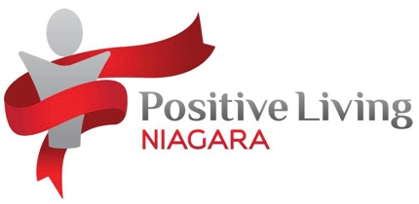
Positive Living Niagara
Positive Living Niagara is a community-based organization dedicated to providing support, education, and advocacy in a safe and confidential environment for HIV/AIDS-positive individuals and their allies, as well as proactive approaches to harm reduction and prevention. Positive Living Niagara offers counselling services and individualized home support. This organization is inclusive to members of the trans* and two-spirit communities, including HIV/AIDS testing, and offers needles and other injection supplies for free to those who need them for hormone injections/safer use. Staff are knowledgeable about HRT and can advise the best options for you if unsure. PLN also offers a StreetWorks van, which delivers supplies to your location when called.
Contact information
Location: 120 Queenston Street, St. Catharines (right side door for injection supplies)
Phone: (905) 984-8684
Email: info@positivelivingniagara.com OR sburtch@positivelivingniagara.com
Facebook: Positive Living Niagara
Twitter: @poslivngniagara
Instagram: positivelivingniagara


OUTNiagara
This is a non-profit community organization that aims to unite Niagara’s sexual and gender diverse communities. OUTNiagara provides an online hub for LGBTQIA+ events, news, and resources in the Niagara region. This organization also maintains an on-going directory of businesses in the Niagara region that are safe for the sexual and gender diverse community.
Contact Information
Website: http://www.outniagara.com/
Email: info@outniagara.ca
Facebook: OUTniagara
Twitter: @outniagara

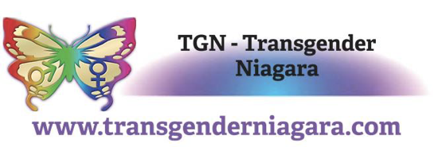
Transgender Niagara
A trans* peer support group in St. Catharines whose primary purpose is to provide the trans* community with access to information, resources, and companionship. This group hold monthly meetings for trans* people of all ages, with a focus on mature individuals, as well as partners and allies. Transgender Niagara acts as both an activist group for trans* and queer individuals as well as a social support system within the community. Meetings are held on the fourth Tuesday of every month at the Silver Spire Church (366 St. Paul Street, St. Catharines).
Note: TGN prefers the use of “trans*” to “trans”, which is the reason for the inclusion of the asterisk in this section.
Contact information
Email: mctigue.colleen@gmail.com
Facebook: TGN – Transgender Niagara

Niagara Transgender Action Coalition
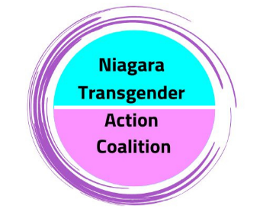
Niagara Transgender Action Coalition (NTAC) is a group of community members and service providers who are committed to supporting and elevating transgender folks in the Niagara region through engaging in advocacy work, providing access to pre and post surgery kits, and planning community events. Contact information is below. Reach out to request resources or inquire about how you can get involved.
Contact Information
Website: https://pflagniagara.ca/ntac/
Email: ntac@pflagniagara.ca


PFLAG Niagara
In communities across the country, the Pflag Canada network provides peer support, education and advocacy for a Canada that affirms respects and values all sexualities, genders and gender expressions. Pflag’s Niagara chapter offers monthly peer support meetings, a confidential telephone support line, lending library, and participates in/presents local events supporting Niagara’s 2S&LGBTQ+ community. Pflag also offers a My Name Fund which helps fund the costs of legal name changes.
Contact Information
Website: pflagniagara.ca/
Niagara Representative: Kim
Phone: 1-888-530-6777 ext. 600
Email: niagaraon@pflagcanada.ca
Note: Meetings are the second Tuesday of each month from 7pm-9pm


LGBT Youthline
This service is a Canada-wide resource for all 2S&LGBTQIA+ youth that is anti-oppressive, anti-racist, accessible, sex positive, indigenous inclusive, and confidential. The LGBT Youthline offers a variety of services, including a 2S&LGBTQIA+ hotline, online confidential chats, text hotlines, and links and resources covering a wide variety of topics including the relationships between sexual/romantic/gender identity, religion, mental health, physical health, sexual health, government forms, service providers, education, family, homelessness, and self-care. This non-profit organization also provides a simple referral database for 2S&LGBTQIA+ youth to use to find any resources they need in their community that are safe and inclusive.
Contact Information
Phone: +1 (800) 268-9688 (toll-free, will not show up on phone bill for confidentiality)
Text: (647) 694-4275 (will not show up on phone bill for confidentiality)
Email: askus@youthline.ca
Website: www.youthline.ca
Twitter: @LGBTYouthLine
Facebook: LGBT Youth Line
Instagram: lgbtyouthline

On-Campus Trans, Nonbinary, and Two-Spirit Groups and Supports


Human Rights and Equity Office
The Human Rights and Equity (HRE) Office is a resource for all Brock community members. The work in this office consists of two separate, yet interrelated pieces. First, HRE adheres to and follows the Ontario Human Rights Code, so while we recognize that local issues and events connect to global contexts, our work is focused on being Ontario-centric. HRE addresses human rights, harassment and discrimination through two policies: the Discrimination and Harassment Policy and the Sexual Violence Policy. HRE responds to disclosures of harassment, discrimination and violence through these two policies, and works with claimants and respondents to formulate resolutions. Secondly, HRE offers equity services to staff, faculty, and students by advocating on behalf of individuals and groups of people, by providing education through workshops and other venues, and by offering guidance to those seeking to implement equity in their own working and learning spaces at Brock.
Of note, Brock’s HRE offers peer-2-peer support groups with a focus on gender and sexual-based violence, as well as other specialized topics. To learn more, click here.
Contact Information
Phone: (905) 688-5550 ext. 6859
General Email: humanrights@brocku.ca


Student Justice Centre (SJC)
The Student Justice Centre is a vibrant and inclusive campus community that serves as a hub for social and political engagement, education, and activism. At the SJC, we provide a welcoming and safe space for students to gather, connect with like- minded individuals, and engage in thoughtful discussions about the pressing social issues of our time. Our goal is to empower students to become agents of positive change within their communities and beyond. We offer programs and services that support learning, leadership development, community engagement, activism, advocacy and so much more. The heart of the Student Justice Centre lies in its community, which thrives on student-led activism, creativity and cooperative teamwork between our student leaders and professional staff.

Services
- Free Chest Binder and Breast Form program that offers free gender affirming garments to Brock students (see here for more information).
- Funding and support for students completing social justice projects, initiatives, campaigns, events, and programming on campus.
- Providing a safe(r) space on campus that students can access whenever the door is open and/or through drop-in hour.
- Drop In spaces including: BIPOC Support Drop In, Disability Support Drop In and 2S&LGBTQ+ Adult Drop In which provide peer-to-peer listening and referral support for students who have experienced discrimination, harassment, or violence because of their identity.
- Providing resources and referrals for support with mental illness, sexual violence, 2S&LGBTQIA+ discrimination, racism, ableism and more.
- Free Anti-Oppression Certificate Workshop Series, along with other EDI workshop and trainings available to students, staff, faculty, and community for learning opportunities.
Coordinating the Student Refugee Program at Brock University.
Contact Information:
General Email: sjc@brocku.ca
Website: www.brocku.ca/human-rights/student-justice-centre/
Instagram: brocksjc
Facebook: Brock Student Justice Centre


Brock Pride
A club devoted to creating a safe social environment for Brock members of diverse gender, sexual, and romantic identities. This club aims to provide a community atmosphere which offers support for 2S&LGBTQIA+ people and their allies, as well as pursues the advancement of equality, acceptance, and fair treatment of Pride issues such as same-gender marriage, homophobia, transphobia, heterosexism, and sexual diversity. Weekly meetings are held during the fall/winter terms, as well as multiple events throughout the year.
Contact Information:
Instagram: brockpride
Facebook: Brock Pride
Email: brockpride@outlook.com

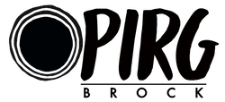
Ontario Public Interest Research Group Brock (OPIRG)
The Ontario Public Interest Research Group (OPIRG) is a social justice non-profit consisting of multiple Action Groups for whom OPIRG provides support, resources, education and promotion. OPIRG does direct-action work (E.g., The Niagara Free Store) and awareness campaigns on several social justice issues. OPIRG is devoted to combatting ableism, supporting neurodiversity, promoting religious tolerance, promoting labour rights and workplace fairness, raising and amplifying marginalized voices, and fighting against racism and white supremacy. This organization provides an intersectional approach to supporting the LGBTQ+ community through volunteer work and activism.
Contact Information:
Website: www.opirgbrock.com
Email: info@opirgbrock.ca
Instagram: opirgbrock
Twitter: @OPIRGBROCK
Facebook: OPIRG Brock


Hadiyaˀdagénhahs First Nations, Métis and Inuit Student Centre
An on-campus centre that focuses on providing a welcoming, supportive, and inclusive environment for Indigenous and non-Indigenous students, staff, faculty, and visitors. This centre strives to help all First Nations, Métis, and Inuit students make a comfortable transition into a university setting by providing support and resources to enhance their academic success and cultural identity. This centre also strives to support and educate all Brock students, staff, faculty, and visitors. Hadiyaˀdagénhahs First Nations, Métis and Inuit Student Centre fosters a safe environment for Two-Spirit individuals, as well as all other members of the LGBTQIA+ community through an intersectional cultural approach.

Services
- Cultural gatherings and teachings, as well as multiple workshops throughout the academic year
- Help with First Nations, Métis and Inuit self-identification at Brock and navigating Brock through an Indigenous lens
- Access to Elder support and traditional medicines for First Nations, Métis and Inuit students
- Connection with local Native Friendship Centres
An office space for students to visit (TH145), which provides Indigenous and non-Indigenous students with an inclusive space that is conducive to learning, including a student lounge, library collection, tea and coffee station, and office space for private meetings and staff
Contact Information
Director: Cindy Biancaniello
Phone: (905) 688-5550 x3361
Email: cbiancaniello@brocku.ca
Student Advisor/Recruiter: Emily Bagshaw
Phone: (905) 688-5550 x3113
Email: ebagshaw@brocku.ca
Instagram: @fnmiscbrocku
Facebook: Hadiya'dagęnhahs - First Nations, Métis and Inuit Student Centre
Office: TH145

Pronouns
All members of the Brock Community are entitled to the use of the gendered pronouns they choose. It is important to respect other people’s pronouns, as using the wrong pronoun can make a person feel disrespected and alienated and can be traumatic over time. Brock University does not tolerate any form of discrimination based on gender identity, sex, or gender expression which includes the purposeful misgendering of others.
Examples of gender-describing/prescribing pronouns include:
He, Him, His
She, Her, Hers
They, Them, Theirs
Ze, Zie, Xe (all pronounced like “Zee”), replaces she/he/they
Hir (pronounced like “here”), replaces her/hers/him/his/they/theirs

Research Ethics and the Collection of Data
The Brock University Research Ethics Board recognizes the false gender binary and the difference between the collection of sex and gender throughout its procedures and decisions. Free tutorials on the collection of sex and gender data and gender education are available for staff through the Canadian Institutes of Health Research (CIHR).
This Board encourages self-identification for gender options in the research that passes through them, such as:
Gender Identity (please specify): ______
Another option commonly used is:
- Male (M)
- Female (F)
- Other (option to specify: ____)
Prefer not to disclose
Gender and/or sex are only able to be collected by researchers if it can be justified based on why the data is relevant to the study. However, typically research journals push for the collection of gender and sex to publish results. The Research Ethics Board at Brock does not have one constant statement on the collection of sex/gender, as it is dependent on the study, but generally encourage options other than strictly Male/Female. The Board is currently working on how to adapt sex-designation to be inclusive of people undergoing Hormone Replacement Therapy (HRT). One suggestion has been to identify as:
- Testosterone-Dominant Body
Estrogen-Dominant Body
Suggestions are also being considered to ask questions about the presence of organs/hormones/bodily functions rather than attributing these aspects to a specific sex.

On-Campus Housing (Residence and Brock Suites) Information

Seeking Accommodations
If you want to request accommodation based on gender identity and/or you are unsure if your needs will be accommodated through the housing application, contact housing@brocku.ca for support.
If you requested accommodations based on gender identity and did not receive them before September, please email housing@brocku.ca. Accommodation requests are given priority for room switches, which can include gender identity as it relates to transgender, nonbinary, Two-Spirit, and gender diverse people. Following in priority after accommodation-related requests are roommate conflict and basic preference requests.

Housing Application Process
The application form for residence prepopulates with your legal name as provided to the university. Some systems used by Housing Services may only provide staff (e.g. Residence Life Staff [RLS]) with the legal name, however, gender-affirming names can be used for door signs, in emails, and handouts if notified. If a student would like to add a chosen name after applying, they can email housing@brocku.ca for guidance on how to have their information updated.
When applying to Residence or Brock Suites, you are currently offered the following options to select for gender identity:
- Woman
- Man
- Two-Spirit (2S)
- Non-binary, Gender Diverse/Fluid or Gender Queer
- I prefer not to answer
I do not see myself reflected in the options
Roommate/house-mate (sharing) options currently include:
- Single gender
- All-gender
No preference
Note: if “no preference” is selected, the default housing protocol currently is to place the individual in an all-gender household. If this option is selected, you will be contacted to clarify your needs and understanding of the option chosen.

Room Switch Requests
If you require a room switch during the school year, you will need to submit a “Request a Room Switch” form. To do this, please follow these steps:
- Go to my.brocku.ca (It is essential that your browser is set up to allow pop-ups/cookies)
- Log in using your Brock credentials
- Click the “Applicant and Student Self Serve” tab
- Click the “Apply for Residence” tab at the bottom right of the page
- Select “Request a Room Switch”
Note: You are only able to request a room switch once. Should you need to make changes to your request, please email housing@brocku.ca

Washrooms
All washrooms and shower facilities are single user within the residential spaces. In addition, they are only accessible by students who live within that area/building.
All-gender washrooms available to all students are available at:
- DeCew (located on the lower level at Stairwells 3, 8, 12, 17)
Residence 8 (located on the main floor in the corridor across from the Service Desk)

The Two-Spirit, LGBTQIA+ and Allies Living Learning Community (LLC)
The Two-Spirit, LQBTQIA+ and Allies Living Learning Community is a community within Brock Residence. This community is open to students who are interested in socializing and living with members of the community, as well as learning more about sexual orientation and gender identity, with a focus on social justice for Two-Spirit and LGBTQIA+ (lesbian, gay, bisexual, transgender, queer, intersex, and asexual) people. This LLC was created to help ease the transition to the Residence community and provide students a safe environment where all residents feel celebrated and empowered. This LLC will focus on the Diversity and Inclusion & Personal Growth domain of the Campus Wide Co-curriculum.
To apply to live in this LLC, please indicate your preference on your residence application and complete the supplemental LLC application.

Student Accounts and Financial Aid
If your gender marker in the Brock system is Other or Undeclared (both represented as O), you will be eligible for all Brock funded scholarships, bursaries and awards, regardless of gender. Brock funded awards that are limited to women or men specifically are very uncommon but are inclusive of transgender students.
Student Accounts and Financial Aid also offers an emergency bursary that is available to students that require it, which can include barriers encountered due to gender identity and funding. Please visit https://brocku.ca/safa for more information and FAQs.

Wellness, Accessibility, and Health Services

Student Wellness and Accessibility Centre
Transgender, nonbinary, and Two-Spirit undergraduate and graduate students who wish to access medical and counselling services can visit the Student Wellness and Accessibility Centre website: https://brocku.ca/swac/.
The Student Wellness and Accessibility Centre and Student Accessibility Services are both located in Schmon Tower, which has a growing number of gender neutral washrooms on these floors. Student Health Services (Harrison Hall) also has 2 gender neutral washrooms.
All information, interactions, and services are confidential to the Student Wellness and Accessibility Centre, Student Accessibility Services, and Student Health Services. This is governed by both the Health Information Protection Act and Brock University’s Freedom of Information and Privacy Protection Policy.
When accessing Brock’s Student Wellness and Accessibility Services, please note the following to receive the highest form of care:
- The name and sex that appear on your OHIP card is the information that will be used in your medical file, as well as anything that is external to Brock University. This may include reporting and billing to the Ministry of Health and requisitions of lab work, such as a referral for blood work or samples from a lab or hospital.
- Forms that are internal to Brock may be signed using a chosen name, provided they have given the correct student identification number so the form can be tracked and scanned into the student’s medical chart. For external forms, such as Release of Information or Authorization forms, a legal name must be used to sign.
- When making a referral, the office will generally use both legal and chosen names and pronouns. Legal name must be present on documents for OHIP billing purposes and for the specialist or lab/diagnostic centre. In the body of referral letters, physicians will always use chosen names and pronouns (provided they are aware of them).
- If you are a member of the Brock Community that has been prescribed Hormone Replacement Therapy (HRT), the Student Health Centre is able to continue to support your care. Anything they are unsure of will be thoroughly researched to ensure the appropriate measures are taken.
- With a filled prescription, nurses can administer HRT injections to students. The clinic can supply Intramuscular Needles (IM) for this purpose. However, nurses do not teach self-administering to students.
If you are interested in possibly pursuing a medical transition through Brock University Student Health Services, any of their physicians can meet with students to discuss the process and next steps, and appropriate referrals will be made.
For students who have a chosen name in their medical records at Brock, a system is in place that alerts intake and medical staff that a chosen name is present, to remind them to use your correct name and pronouns.

Employee and Family Assistance Program
Brock University has partnered with workhealthlife, an employee and family assistance living program, to provide mental health and wellness services for staff and faculty at Brock. By searching “Brock University” on the workhealthlife website (www.workhealthlife.com), employees can access a wide variety of resources related to workplace wellness, including mental health services, counselling, financial planning resources, and articles on dealing with change.
While this resource is notably lacking in transgender-specific content, it does provide some information in general LGBTQ+ matters such as articles about “coming out” at work and creating a LGBTQ+ inclusive workplace.


Canadian Mental Health Association (CMHA): Niagara
The Canadian Mental Health Association is a national organization that promotes the mental health of everyone and supports the recovery of individuals experiencing mental illness. CMHA offers urgent support, walk-in counselling, and short-term counselling.
Contact Information:
Website: www.cmhaniagara.ca
Email: info@cmhaniagara.ca
Phone (for general inquiries): (905) 641-5222

Closing Statement
We at the office of Human Rights and Equity hope that the information in this document is helpful not only to those who identify as transgender, Two-spirit, or nonbinary, but also the wider Brock community who wish to learn more. We will continue to update and add content to this document as the university moves toward becoming a more inclusive and accessible environment for everybody. If you would like to keep up to date with current information and events, please check-out Brock Human Rights and Equity on our social media.
Website: www.brocku.ca/human-rights
Instagram: brockhre
Facebook: brockUHRE
Twitter: @brockUHRE

