

Religious
and Spiritual Accommodation Guidelines

Brock University
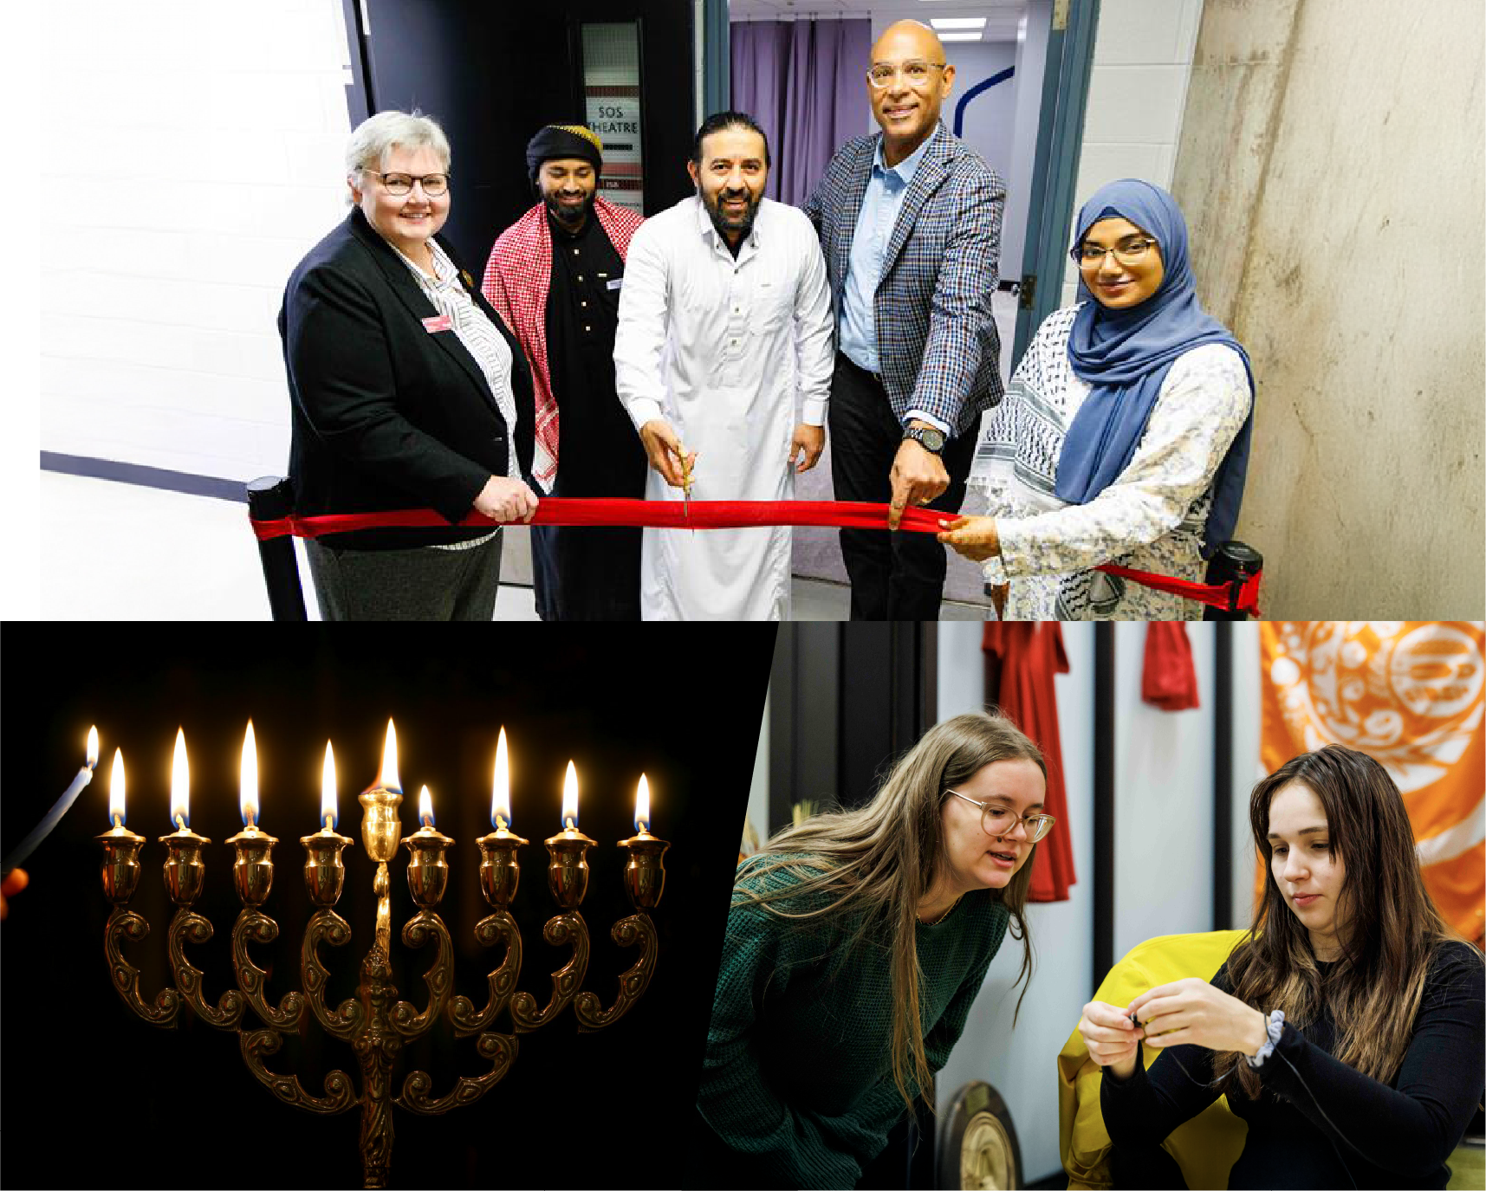

Preamble
Brock University welcomes staff, faculty, and students from a wide range of religious and faith backgrounds and encourages the expression of those beliefs on campus. We recognize that religion, spirituality, and faith are deeply personal and unique for each individual and you have the right to practice your beliefs. This resource provides an overview of the University’s Duty to Accommodate and guidelines for supporting religious and spiritual expressions in workplace and academic settings.

Duty to Accommodate
Under the Ontario Human Rights Code1, Brock University has a duty to accommodate University community members based on their sincerely held creed beliefs and practices.
Creed is broadly understood as a continuum of religious beliefs and practices that govern an individual’s way of life. Those beliefs and practices may not always be associated with an organized religion as we know it. Individuals may practice their faith in unique ways and many factors contribute to this. As individuals move through their personal journeys and experiences it is important to remember the unique nature of one’s beliefs and respect the diversity of practices which exist. However you choose to practice or describe your beliefs, Brock acknowledges and respects you.

What is a Religious Accommodation?
For consistency and readability, we will be using the term “religious accommodation” throughout this document when discussing the duty to accommodate sincerely held creed beliefs. Religion, spirituality, and faith are unique to everyone. Some practices and traditions require its participants to follow guidelines that may conflict with tasks and expectations in the workplace or academic environment. A religious accommodation requires the University, its students and its staff to work together in providing accommodations when an individual’s religious observances or practices create a conflict with their work or learning environment or their schedule. Instead of providing special privileges or advantages, accommodations provide equitable resources for all individuals to ensure they are included and respected.
The following are some common examples of religious accommodation requests in working and academic environments and best practices managers and departmental leaders can take to support their colleagues and students:

- The Ontario Human Rights Code is online ohrc.on.ca



Observation of major holy days, ceremonies, commemorations and celebrations
The request for a religious accommodation may require some modification to the regular day, or a partial and /or full leave or absence for the individual involved.

Examples:
- In many First Nations, Métis and Inuit communities, Full Moon Ceremonies are for women to connect with and honour their Grandmother Moon. Led by a knowledge keeper or an elder, women spend time with each other and their Grandmother for healing, rejuvenation, prayer, song and kinship.
- The Lunar New Year is celebrated by many Asian communities. Family reunions with thanksgiving and remembrance of departed relatives take place. Traditionally, a religious ceremony honours Heaven and Earth.
- Eid is celebrated by many Muslim communities. The celebrations of Eid signify the completion of the Holy Month of Ramadan and can last anywhere between one and four days.
- Rosh Hashanah is the beginning of the Jewish New Year and first of the High Holy Days. Rosh Hashanah is observed for two days.

Best practices:
Consider how individuals might be commemorating that observance and how you can support them on that occasion. For example, you may want to avoid scheduling major deadlines, due dates, events, meetings or other activities at this time. Students may likely request accommodation for absences and staff may request to have the day off so it’s best to prepare in advance for these absences.



Prayer and spiritual practices
Some religions and faiths assign great significance to prayer and worship amongst its members. The requirements around prayer are tied to specific days and times when it needs to be offered which may create a conflict with their work or academic schedule.

Examples:
- Smudging is a tradition, common to many First Nations, Métis, and Inuit communities, that involves the burning of one or more medicines gathered from the earth. The four sacred medicines used in many Indigenous communities’ ceremonies are tobacco, sage, cedar, and sweetgrass. The forms of smudging will vary from nation to nation but are considered to be a way of cleansing oneself. Smudging allows people to stop, slow down, and become mindful and centered. This allows people to remember, connect and be grounded in the event, task or purpose at hand. Brock’s smudging ceremony consideration can be located here: brocku.ca/human-resources/wp- content/uploads/sites/81/Smudging-Ceremonies-on-Campus.pdf
- For Muslim community members, Friday is the day for congregational worship in Islam, called Jummah. Jummah usually lasts about 45 minutes to one hour. The requirements of Jummah include a short sermon followed by a prayer performed in congregation. Brock community members may need to leave their regularly scheduled activities (i.e. class, work, etc.) to complete their practice.
- Students may request accommodations for Shabbat observance when Friday evening or Saturday classes or exams conflict with their religious practice.

Best practices:
Direct faculty and staff to the available multi-faith prayer spaces on campus. If possible, offer a private space in your department devoted to religious, spiritual and personal contemplation. Consider not scheduling meetings or due dates on recurring prayer times that you are aware of.



Dietary needs
Individuals may have certain dietary needs and restrictions. This could include abstaining from certain types of food/drink or requirements that some forms of food be prepared using a specific method. It is important to adhere to the specificities required of the individual making the request.

Examples:
- Many Hindus are vegetarian, and some are lacto-ovo (milk-egg) vegetarians. Meat, fish, eggs and dairy products are not allowed in these diets.
- Muslims follow an Islamic dietary law which prohibits the consumption of alcohol, pork and any pork by-product or derivatives. Islamic dietary law requires meat and poultry to be halal (prepared to a specific standard).
- Many members of the Jewish community comply with Kosher dietary guidelines. These laws determine which foods may be consumed and how they must be produced, processed, and prepared. Strict kosher observance requires any processed or prepared food to be Kosher certified. Also, certain categories of food cannot be cooked or eaten together. Kosher food is either categorized as meat or fleishig, dairy or milching, and pareve. There are various levels of Kosher observance, some people are strict when it comes to the meat category only, but are more lenient on dairy and pareve items. Some people are strict on all categories, with an additional requirement for dairy products to be Chalav Yisrael (Kosher dairy, without the mention of Chalav Yisrael, doesn’t meet their Kosher dietary requirements).

Best practices:
When planning events, be attentive to the dietary restrictions and needs of individuals. Consideration should be made to provide a variety of options including, but not limited to, kosher, halal and vegetarian options. Special care must be taken to keep vegetarian and non-vegetarian food separate, and to ensure that the same spoons and serving utensils are not used to serve both kinds of food. Food and snacks that have been prepared using animal byproducts (e.g., lard, beef tallow, gelatin) should be properly labeled.



Fasting
Individuals may participate in a fast as an expression of their religion or faith. Fasting includes, but is not limited to, abstaining from food and drink.

Examples:
- The annual fast in the Baháʼí faith occurs from March 2-20. Baháʼís do not eat or drink from sunrise to sunset on each of the 19 days. It is obligatory for all those who reach the age of 15.
- Ramadan is considered the most sacred month in the Islamic calendar. Muslims (who are able to) will fast from sunrise to sunset. Fasting means no food and no water. During Ramadan, gathering and prayers often last late into the night; people may be up past midnight for prayers and then awake early in the morning to eat before sunrise.
- The Nativity Fast is observed in preparation for the celebration of the Nativity of Christ (Christmas). It typically lasts for 40 days.

Best practices:
Consider the timing and impact of fasting on students’/faculty and staff when scheduling deadlines and due dates during significant holidays. Consider offering take-aways for students/faculty and staff who are fasting. Dining services can offer overnight packages to break or open a fast.



Religious dress
Individuals may wear clothing or religious symbols in accordance with their religion or faith. Some religious attire may include, but is not limited to:
- Hairstyles: ex. Rastafari students and colleagues may keep their hair uncut and untouched as a vow or a covenant with their creator.

- Headwear: ex. Muslim women may wear a hijab (head covering) as an expression of their faith, Members of the Jewish community may wear a kippah, or yarmulke, a cap that covers the crown of the head and others may wear a headcovering.

- Religious symbols: ex. Baptized Khalsa Sikhs are required to wear a Kirpan - a ceremonial sword that is a symbolic reminder to stand up against injustice.

- Religious dress: ex. Muslim women may wear a Niqab (veil covering the hair and face) as an expression of their faith.

Best practices:
Accommodate religious attire and other religious symbols when there are no health and safety risks involved.



Death of a loved one and bereavement period
The death of a loved one may present challenges when navigating the working and/or learning environment and may require a period of mourning, observance, and/or bereavement.

Examples:
- The period of mourning in the Jewish faith may take up to seven days after burial.
- The period of mourning in some Indigenous communities may take up to ten days. The Brock community should also consider that many First Nations, Métis, and Inuit students, staff, and faculty may need time to travel to remote communities, which would extend their grieving time.

Best practices:
Be flexible and recognize norms between and within communities. Consider how individuals might be commemorating that observance and how you can support them on that occasion. For faculty and staff, contact People & Culture for questions regarding time off and supports. For students, contact Human Rights and Equity for guidance related to time off and supports.



Indigenous Ways of Knowing,
Being and Doing2
Brock University is committed to fostering a culture of inclusivity, reconciliation and decolonization. Brock honors Indigenous Ways of Knowing, Being and Doing and recognizes how accommodations for religious/spiritual needs differ from various communities. Indigenous Ways of Knowing, Being and Doing refers to the diverse, complex and unique Indigenous ways of learning and teaching. Several themes are common across First Nations, Métis, and Inuit communities including approaches to knowledge that are embedded in the metaphysical, holistic, oral/symbolic, relational and intergenerational. Indigenous communities have deep respect for the land and believe that their actions today have an impact on the next seven generations.
As Brock continues its journey towards reconciliation - we acknowledge the diverse practices and beliefs of Indigenous communities and are committed to fostering culturally responsive and culturally safe spaces for Indigenous community members. We work to learn and unlearn our assumptions of “knowledge” and actively grow as an institution to provide equitable resources to all peoples.

- This section will be revised under the direction of the Office of the Vice-Provost, Indigenous Education, and Hadiya’dagénhahs First Nations, Métis and Inuit Student Centre. Anticipated sections to be revised are noted throughout this document via yellow highlights.

Supporting religious and spiritual
accommodations for staff and faculty

How do I request religious accommodation?
You are responsible to inform your manager/departmental leader in writing, as soon as possible if you require religious accommodation. Some helpful tips you may consider when requesting an accommodation include:
- Familiarize yourself with the relevant policies available and consult your respective employee handbooks and collective agreements to understand what is available to you.
- Provide clear guidelines for the accommodations you need and work with your manager or departmental leader to ensure those needs are met.
- To the best of your availability, provide notice when requesting time off. Recognizing this may not always be possible, this helps prepare in advance for your absence.

Scheduling requests for faculty
As stated in the collective agreement between Brock University and Brock University Faculty Association (BUFA), faculty members may submit scheduling requests related to protected grounds in accordance with the Ontario Human Rights Code and that may require accommodation to the point of undue hardship. Such requests must be in writing and shall be submitted to the Registrar’s Office prior to September 30 for the Spring/Summer terms and November 30 for the Fall/Winter terms. If the Registrar’s Office determines that a member’s request falls short of the standard for accommodation, the member may opt to subsequently have their request considered as per the process outlined below.
- Requests must be submitted by November 15 for the Spring/Summer terms and by January 15 for the Fall/Winter Terms or, where applicable, within 10 working days the member received notice of the denial of a human rights accommodation, whichever is later.
- The University will provide the Union with a report of scheduling requests and final decisions related to the above.

Considerations for managers
/departmental leaders:
Managers and senior departmental leaders should take a proactive approach with the employee requesting an accommodation. The following tips may be considered useful when considering religious accommodations in the workplace:
- Treat accommodation requests as sincere. Accept the person’s request in good faith, unless there is clear evidence to believe otherwise. Documentation from faith leaders is not required.
- Only request information that is required to make the accommodation - for example, you may ask the employee requesting a dietary accommodation for a list of permissible and non-permissible food options.
- Take an active role and work with the employee to find the best accommodation possible as the circumstances permit.
- Deal with accommodation requests in a timely way.
- Consult People & Culture or the Human Rights and Equity Office for advice and feedback.
- Keep a record of the accommodation request and action taken.

Frequently asked questions:
Religious and spiritual accommodations for staff and faculty

Q: If a staff or faculty member requests time off from work to participate in a religious or spiritual holiday/observance, which is not included in the list of statutory holidays provided by the University, must I grant the request?
A: The University is required to provide staff and faculty who are members of a minority religious faith the opportunity to take time off without loss of pay to celebrate their religious holidays, to the point of undue hardship. You should offer the employee options to have the time off without losing wages or using vacation time (e.g. options might include scheduling changes, overtime, use of lieu time). If the employee’s role or circumstances are such that they cannot make up the time that they must miss for religious reasons, other forms of accommodation must be explored. The Office of People and Culture can be contacted for further support.

Q: If a faculty or staff member makes a last-minute request to take a day off to participate in a religious or spiritual holiday/observance, must I grant this short notice request?
A: Yes, despite the short notice, you are required to provide the employee with time off. However, employees are expected to provide reasonable notice of the leave request.

Q: If a staff or faculty member has not yet completed their probationary period, are they entitled to time off for religious observances or practices?
A: Yes, the University’s obligation to accommodate extends to all employees, regardless of their length of service with the University

Supporting religious and spiritual accommodations for students
Brock University acknowledges the diverse nature of the undergraduate and graduate communities and has a duty to accommodate requests by students who, by reason of religious obligation, must miss an examination, test, assignment deadline, seminar, lab or other compulsory academic event.

How do I request religious accommodation?
Students requesting academic accommodation based on religious obligations must make a formal written request to their instructor(s) for alternative dates/and or means of satisfying requirements. Use the email template on page 18 to ensure your requests include all the necessary components. Such requests should be made during the first two weeks of any given academic term, or as soon as possible after a need for accommodation is known to exist (assignment due date is announced), but in no case later than the second-last week of classes in that term. You should:
- Request accommodation at the earliest possible opportunity or as soon as you identify a need for accommodation - for example, you may not identify the conflict until the posting of the examination schedule is released.
- Provide written request for the accommodation (see email template on page 18) and any other supporting documents that is reasonably requested
- Work with your instructor regarding your request and be open to ongoing dialogue

Considerations for instructors
Instructors should make every effort to avoid scheduling academic deadlines, tests or labs on religious and spiritual days of observance. Class syllabuses should include the Request for Religious Accommodation Form (see pages 19-20).
If an accommodation request is received, you should:
- Treat accommodation requests as sincere. Accept the person’s request in good faith, unless there is clear evidence to believe otherwise. Documentation from faith leaders is not required.
- Once a written request is received, accommodation could include rescheduling of assignments, labs and exams or providing alternative materials in specified labs.
- Work with the students to provide reasonable accommodation.
- Every effort should be made to avoid an accommodation that disadvantages a student - for example, consider deferring final exams, assignments or labs to a date within the regularly scheduled exam period as opposed to the next semester.
- If you have any questions or concerns about religious accommodation, consult People & Culture or the Human Rights and Equity Office for advice.

Frequently asked questions:
Religious and spiritual accommodations
for students

Q: How can I determine if a religious belief is “sincerely held”? Can I ask for this information?
A: Religious accommodation requests should be considered sincere and accepted in good faith unless there is clear evidence to believe otherwise. Documentation from faith leaders is not required.

Q: Is it safe to assume that others who practice the same religion share the same beliefs and practices?
A: No. Religion and spirituality are unique to everyone. It is important to recognize the diversity of beliefs, perspectives and practices and how they may manifest differently from person to person.

Q: Who can I contact if an instructor has denied my request for religious accommodation?
A: Any questions pertaining to religious accommodations can be sent to the Human Rights and Equity Office.

Multi-faith prayer spaces on campus
Set into the escarpment, right on the Bruce Trail, the Faith and Life Centre (FLC) is a peaceful escape from the bustle of the University campus. The FLC is a space for all students, and all student clubs-religious or otherwise. The space is designated as a drop-in quiet study space which is also used for religious practices, i.e. prayer groups, Bible studies, and discussion groups. The FLC includes the following dedicated quiet rooms for prayer, reflection and contemplation:

Muslim Prayer Room
The Prayer Room is at Alphie’s Trough with another temporary location at Rita Welch Centre. Jummah prayer is held in the Faith and Life Centre at 1:00 pm on Fridays.

Wudu stations
The Wudu station is in the Rankin Family Pavilion, close to the library, across from the elevators leading up to the 13th floor.

Rita Welch Meditation Centre
The Rita Welch Meditation Centre is in the McKenzie Chown A building, beside the Sankey Chambers.
It is a drop-in quiet space for meditation or prayer. Individuals should be respectful of one another’s privacy. The centre is occasionally used for campus student or departmental meetings. Contact Chaplain Zack DeBruyne for further information about booking the space: zdebruyne@brocku.ca

Email Template
Greetings (Insert Instructor Name),
I am sending this email as a formal request for an accommodation in (insert course title and code). As indicated in section 13.2.3 Accommodation of Students on Religious Grounds in the Faculty Handbook Section 3: Academic Regulations, I am informing you of this at my earliest notice that such a conflict exists.
I am requesting an accommodation from the (exam, lab, test, assignment etc) scheduled on (date) due to a conflict with the celebration/commemoration/ of (observance) which I will be participating in, scheduled on the same day. Recognizing that accommodations must be worked out with the instructor and student, I have listed a few possible alternatives to writing the (midterm, exam, lab etc) on the scheduled date. These include:
- Writing the exam on another date during the same academic term
- (list other accommodations if you have any)
If you agree with these accommodations, please send me an email to confirm. If you have alternatives to this accommodation or would like to discuss this further, please do not hesitate to let me know. Looking forward to hearing from you soon.
Best,
(Your name)

Request for Religious Accommodation Form
This form is to be used to request academic accommodations for religious reasons. It is the responsibility of the student to inform their instructor of the conflict as early as possible once the announcement of a due date or examination schedule is posted.

For term work, this form must be completed within of the start of term, or within of the announcement of a due date, whichever is later.

For final exams, this must be completed within of the announcement of the examination date.

If the dates are not well known in advance, this form should be completed within
of identification of such conflict.

If the conflict is not for the full day, this should be included in the “Additional Notes” section.
Note: Accommodation is to be worked out directly and on an individual basis between the student and the instructor(s) involved. Any dispute unresolved by discussion between the student and instructor may be appealed, first to the Department/Center Chair/Director and thereafter to the Dean of the Faculty in which the student is registered. If the student is not satisfied with the decision of the Dean, the student may then appeal to the Student Appeals Board.

Relevant Contacts:
First Name:
Last Name:
Brock Email Address:
Student Number:
Academic Term:
Request accommodation for:
- Mid-term
- Test
- Labs
- Exam
Request:
Date of conflict:
Additional conflict dates:
Religious Observance: Please name the religious observance which creates the conflict.

Additional Notes: Please provide any other relevant information to support the request.

Acknowledgement:
I confirm that the information provided is true and accurate.

Date of submission:

